# GoNoGo Heat Map®

## Cross-Asset Comparison of GoNoGo Trend

* Equities sees the “Go” trend continue this week and the indicator paints strong blue bars
* Treasury bond prices showed uncertainty this week with amber “Go Fish” bars
* Commodities saw strong blue “Go” bars this week
* Dollar saw the “Go” trend remain in place and strong blue bars returned

# GoNoGo RelMap®

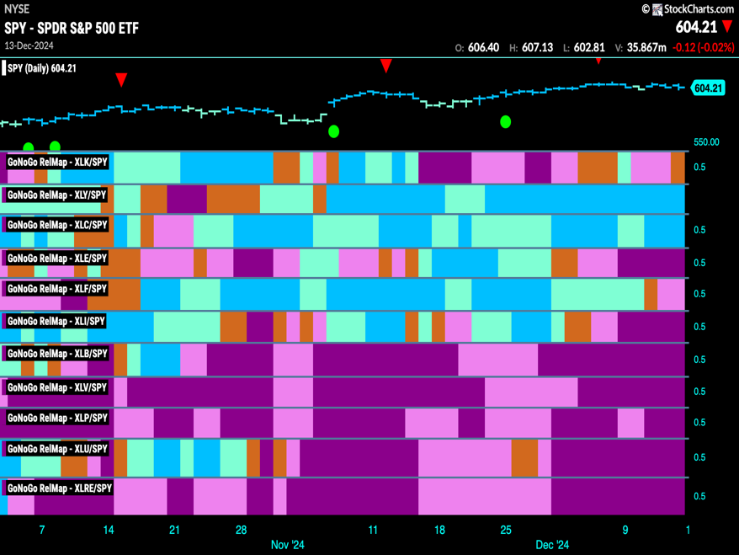GoNoGo Trend *of* Sectors’ Relative Strength to $SPX

* 2 sectors outperformed the broad S&P 500 Index to end this week
* $XLY, $XLC are in “Go” trends on a relative basis

# Fixed Income

## Investment Grade Corporate Bonds - $LQD

* GoNoGo Trend showed that the trend gave way to an amber “Go Fish” bar of uncertainty
* GoNoGo Oscillator is testing the zero line from above where we will watch to see if it finds support

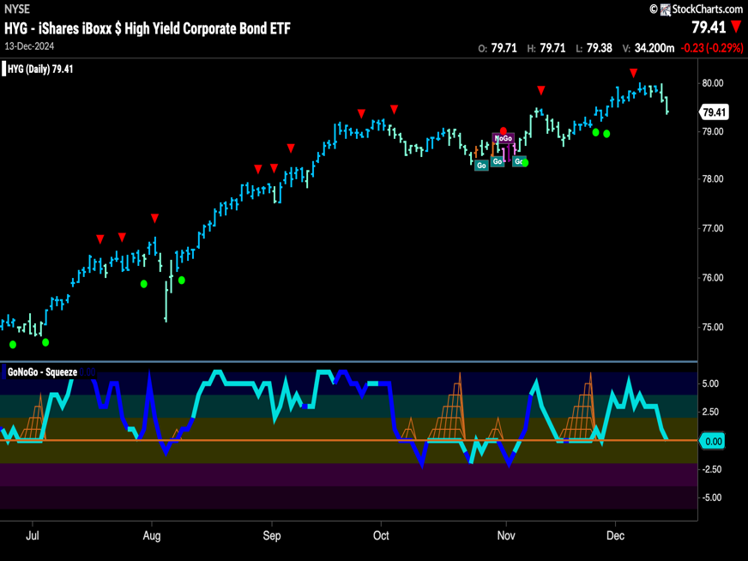High Yield Bonds - $HYG

* GoNoGo Trend saw the “Go” trend remain but the indicator shows some weakness with aqua bars
* GoNoGo Oscillator is testing the zero line from above where we will watch to see if it finds support

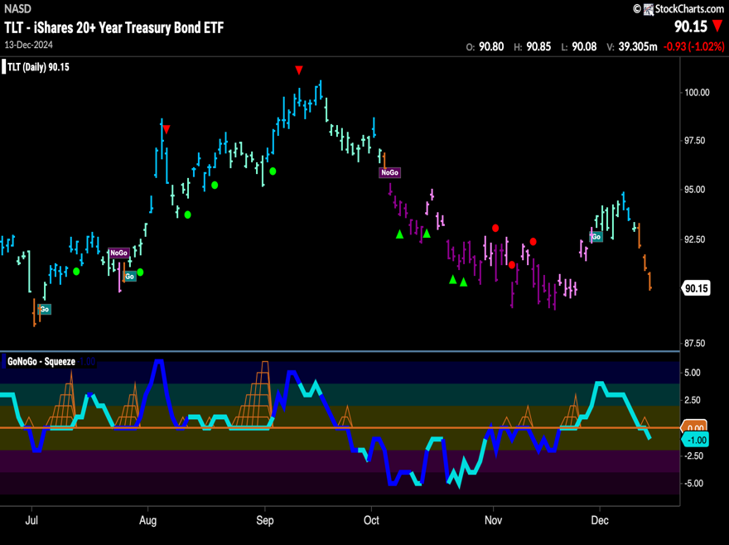Government Treasury Bonds - $TLT

* GoNoGo Trend saw a “Go” trend give way to amber “Go Fish” bars of uncertainty
* GoNoGo Oscillator is breaking down into negative territory

# spy Equities

## U.S. Large Cap - $SPY

* GoNoGo Trend sees the “Go” trend continue this week the indicator paints strong blue bars
* GoNoGo Oscillator is testing the zero line from above where we will watch to see if it finds support

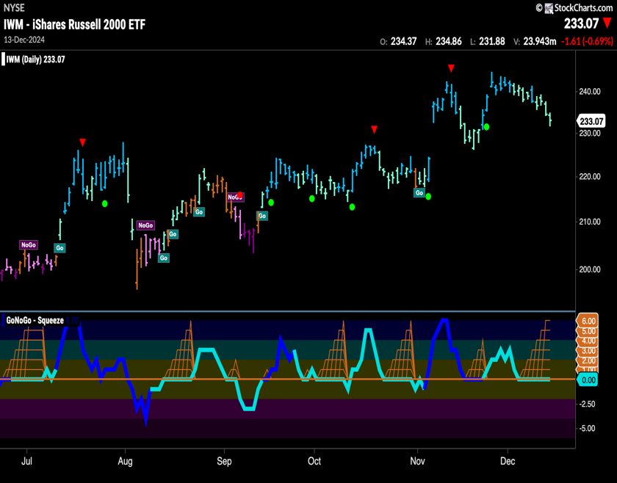U.S. Small Cap - $IWM

* GoNoGo Trend shows the “Go” trend survives but we continue to see weaker aqua bars
* GoNoGo Oscillator is testing the zero line and we see a Max GoNoGo Squeeze

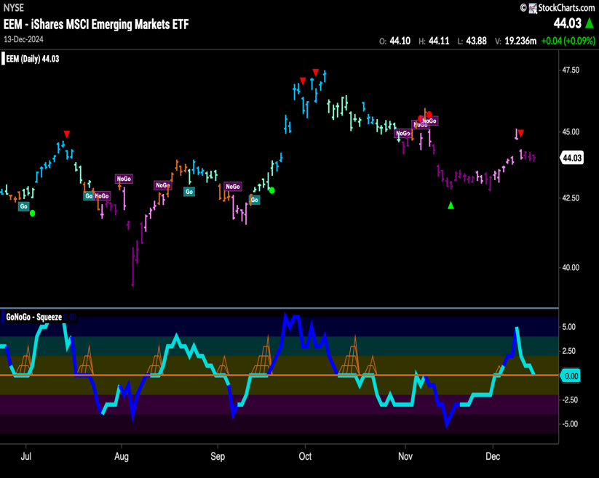Emerging Markets - $EEM

* GoNoGo Trend shows the “NoGo” remained in place and we see strong purple bars
* GoNoGo Oscillator is testing the zero line from above where we will watch to see if it finds support

# Commodities

# Gold - $GLD

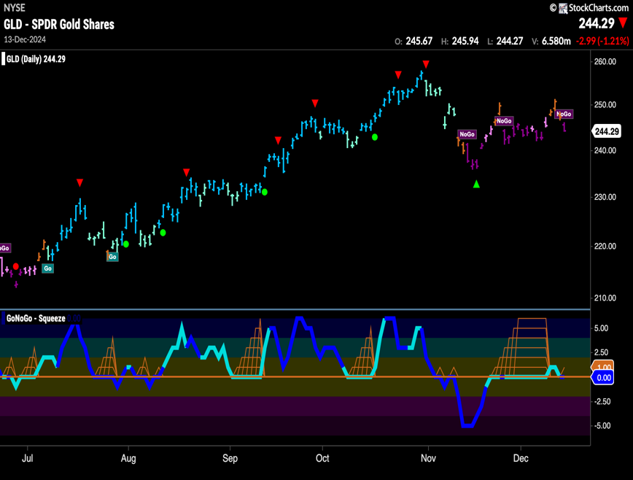

* GoNoGo Trend shows the “NoGo” return after a few amber bars
* GoNoGo Oscillator is back at the zero line after briefly breaking out of a Max GoNoGo Squeeze into positive territory

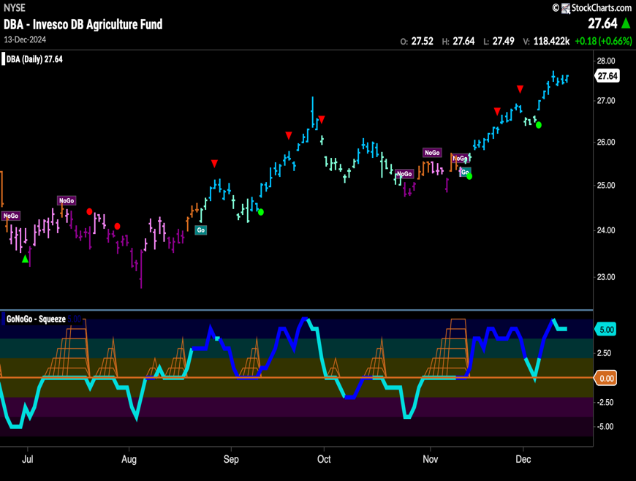Agriculture – $DBA

* GoNoGo Trend shows the “Go” trend remained in place this week with strong blue bars at new highs
* GoNoGo Oscillator is at a value of 5 and overbought

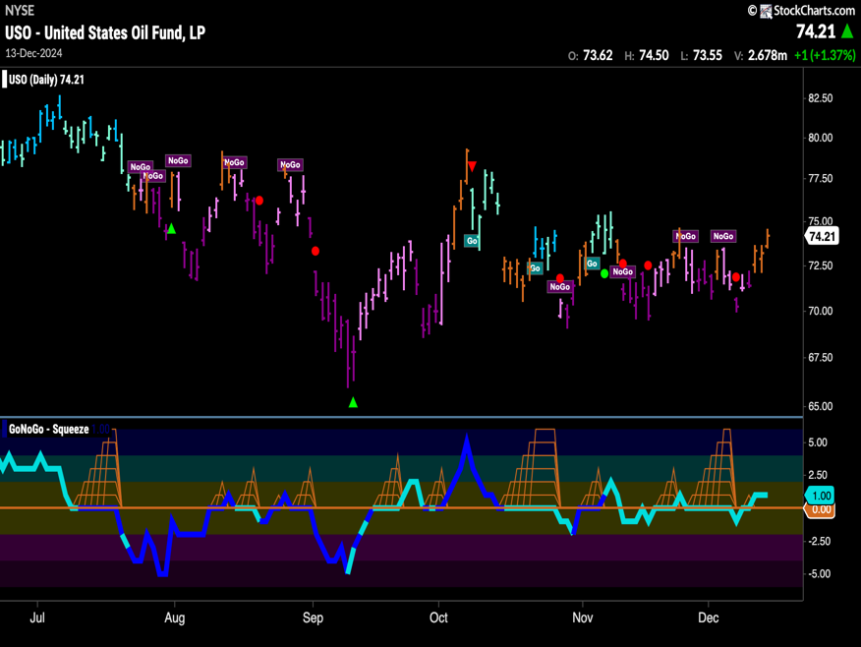Oil - $USO

* GoNoGo Trend shows “Go Fish” bars this week
* GoNoGo Oscillator has reversed course and is back in positive territory

# Currencies

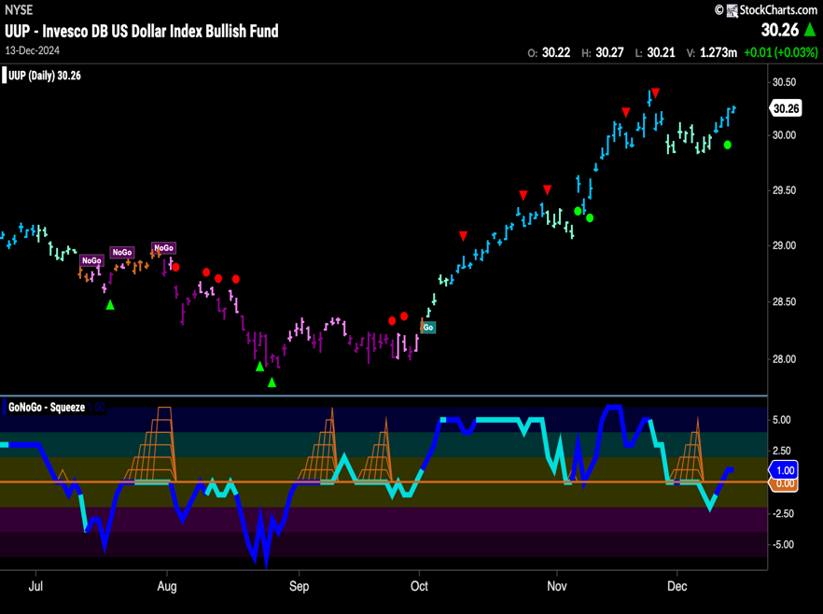The Dollar - $UUP

* GoNoGo Trend shows the “Go” trend strengthens again this week on strong blue bars
* GoNoGo Oscillator is back in positive territory on heavy volume

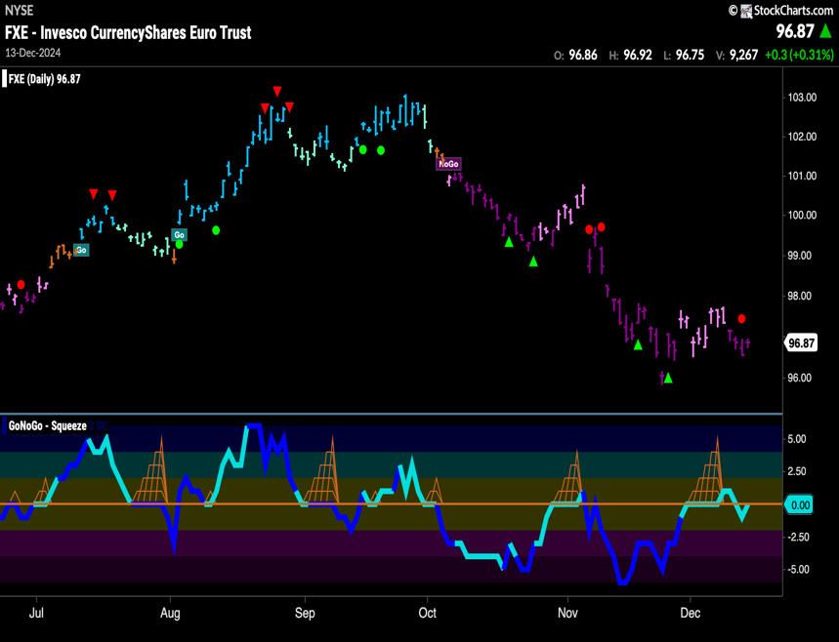The Euro - $FXE

* GoNoGo Trend shows that the “NoGo” survived another week and we see strong purple bars
* GoNoGo Oscillator is back at zero after having briefly moved into negative territory

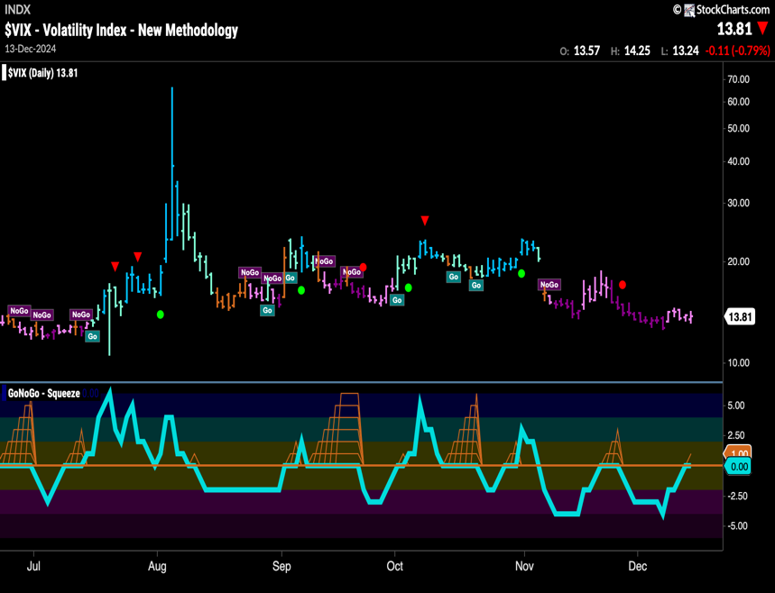Volatility - $VIX

* GoNoGo Trend shows volatility remains in a “NoGo” trend this week but the indicator paints weaker pink bars
* GoNoGo Oscillator is back testing the zero line from below

# Cryptocurrency

## Bitcoin - $BTCUSD

* GoNoGo Trend shows that the “Go” trend continues and we see strong blue bars as price tries to make higher highs
* GoNoGo Oscillator continues to find support at the zero level

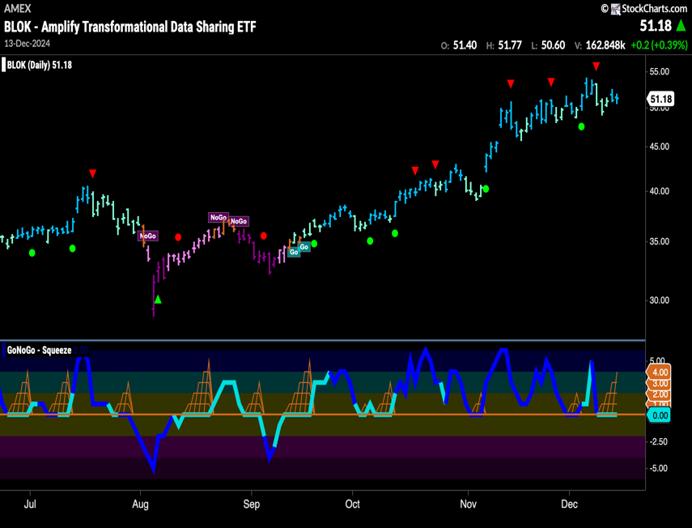Crypto Fund - $BLOK

* GoNoGo Trend shows that the trend remains in a “Go” trend and we see bright blue “Go” bars as tries to remain close to prior highs
* GoNoGo Oscillator is riding the zero line and we see a GoNoGo Squeeze build

Top 5 Stocks in “Go” Trends

## Trend Continuation on Rising Momentum

GoNoGo Charts® highlight low-risk opportunities for trend participation with intuitive icons directly in the price action. The resurgence of momentum in the direction of the underlying price trend is an excellent entry opportunity, or the chance to scale up positions.

GoNoGo Icons® illuminate these events on the chart with green solid circles (or red circle to highlight continuation of NoGo trends). When GoNoGo Trend® is painting **blue** or **aqua** bars, a green solid circle will appear below price each time GoNoGo Oscillator® finds support at zero.

#### Below are the top 5 stocks/ETFs in “Go” trends with surging momentum by volume in the S&P 500 as of the daily closing price action:

### Archer Aviation Inc. – (ACHR)

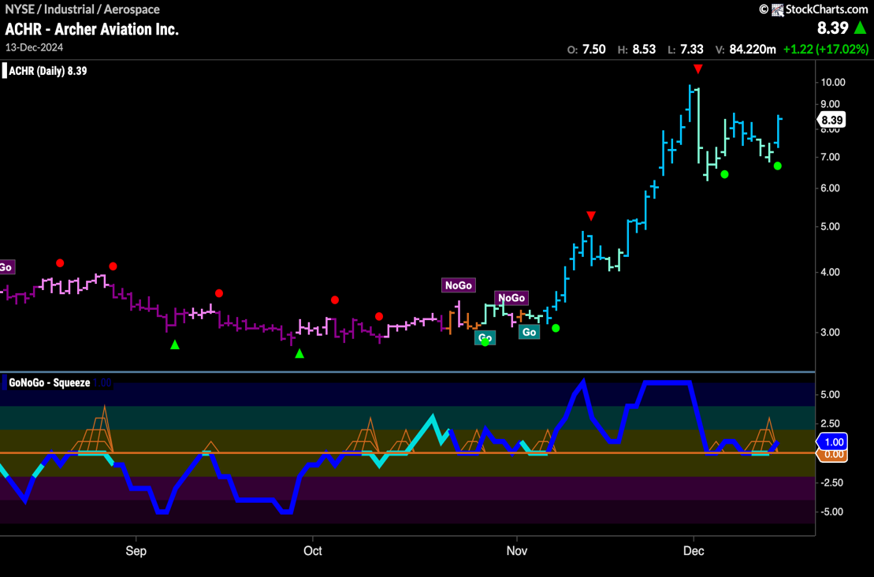

* GoNoGo Trend is painting “Go” bars as price tries to set up for a new high
* GoNoGo Oscillator has found support again at zero on heavy volume

### D-Wave Quantum Inc. ( QBTS)

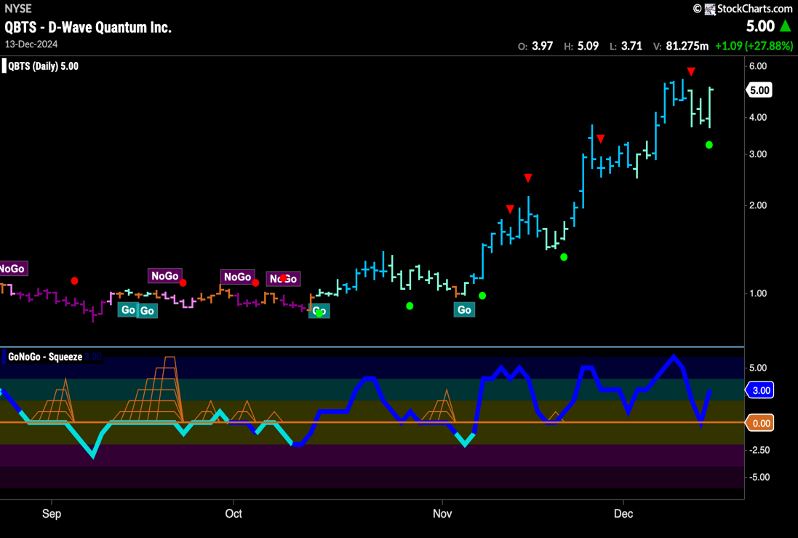

* GoNoGo Trend is painting “Go” bars as price tries to make a new high
* GoNoGo Oscillator is bouncing back into positive territory on heavy volume

### Riot Platforms, Inc. (RIOT)

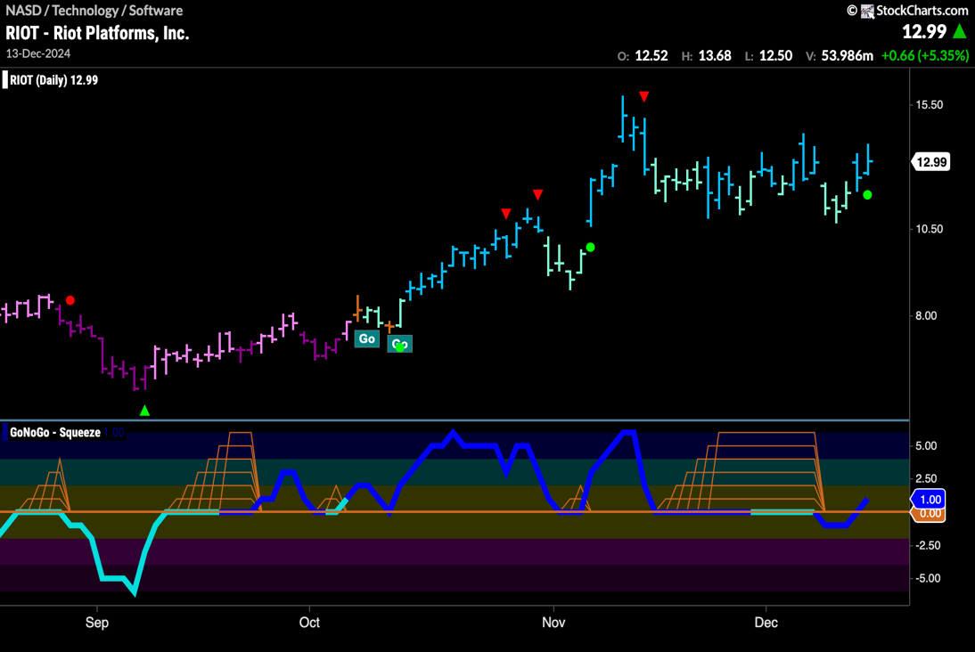

* GoNoGo Trend is painting “Go” bars as consolidates sideways
* GoNoGo Oscillator is moving back into positive territory on heavy volume

### SoFi Technologies, Inc. (SOFI)

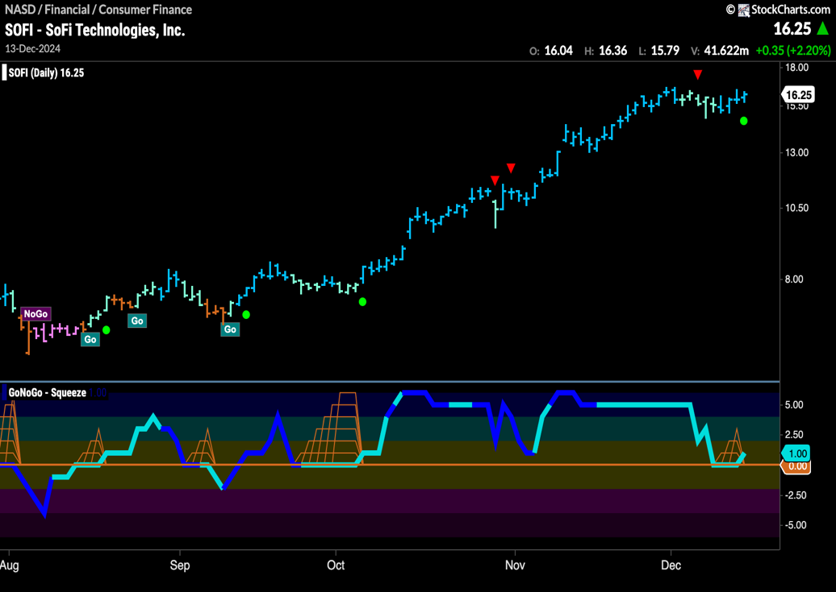

* GoNoGo Trend is painting strong blue “Go” bars as price tries to set a new higher high
* GoNoGo Oscillator has found support again at the zero level

### AT&T, Inc (T)

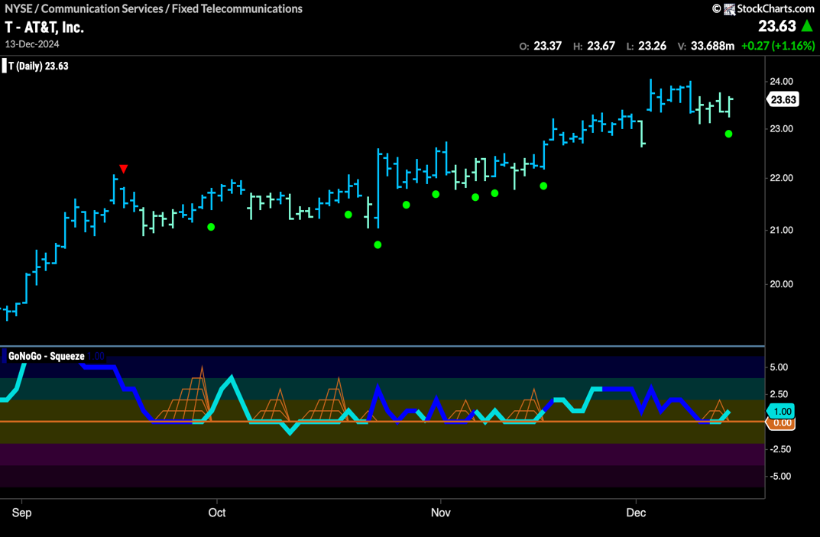

* GoNoGo Trend is painting blue bars as price tries to set up for new highs
* GoNoGo Oscillator is moving off the zero line back into positive territory