# GoNoGo Heat Map®

## Cross-Asset Comparison of GoNoGo Trend

* Equities sees the “Go” trend continue again this week with consecutive bright blue bars
* Treasury bond prices saw mostly pink bars this week
* Commodities saw the “Go” trend continue but the indicator painted mostly weaker aqua bars
* Dollar saw the “Go” trend remain in place with a week of strong blue bars

# GoNoGo RelMap®

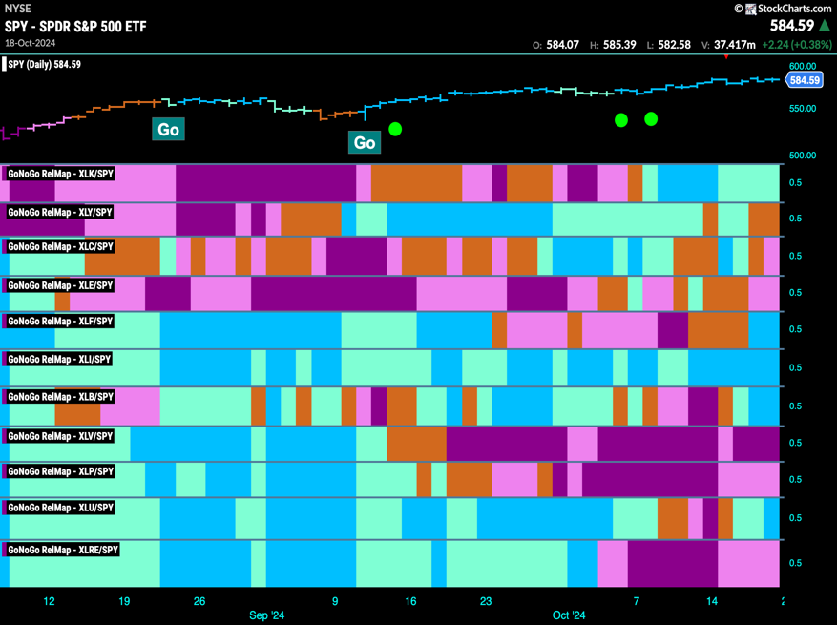GoNoGo Trend *of* Sectors’ Relative Strength to $SPX

* 5 sectors outperformed the broad S&P 500 Index to end this week
* $XLK, $XLF, $XLI, $XLB, and $XLU are in “Go” trends on a relative basis

# Fixed Income

## Investment Grade Corporate Bonds - $LQD

* GoNoGo Trend showed that price remained in a “NoGo” trend this week
* GoNoGo Oscillator is in negative territory having been rejected at the zero line

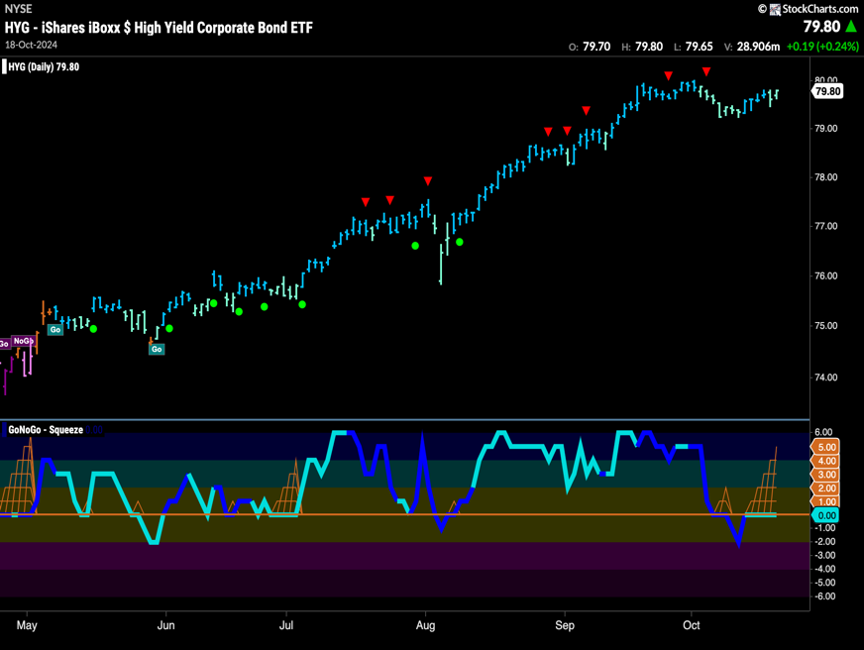High Yield Bonds - $HYG

* GoNoGo Trend saw the “Go” trend continue but we see weaker aqua bars
* GoNoGo Oscillator is riding the zero line and we see a GoNoGo Squeeze close to its max

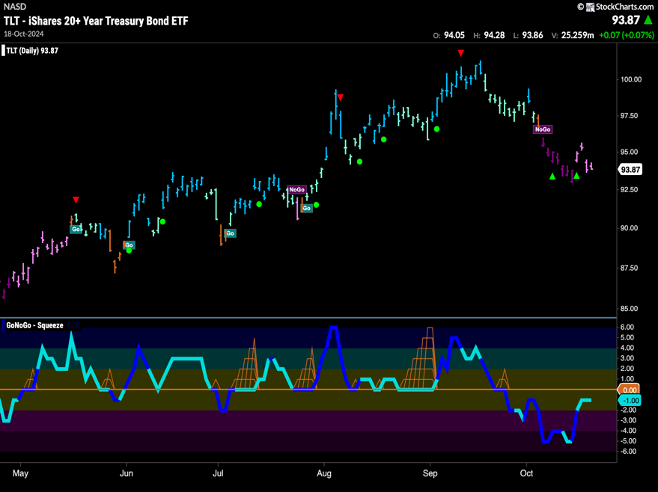Government Treasury Bonds - $TLT

* GoNoGo Trend saw the “NoGo” continue but with mostly weaker pink bars this week
* GoNoGo Oscillator is at a value of -1 on light volume

# spy Equities

## U.S. Large Cap - $SPY

* GoNoGo Trend sees the “Go” trend continue this week as we saw strong blue bars again at new highs
* GoNoGo Oscillator is in positive territory but no longer overbought

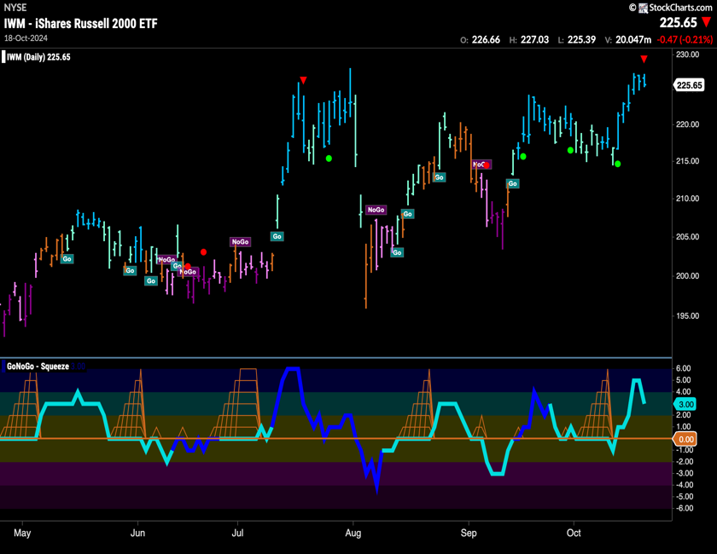U.S. Small Cap - $IWM

* GoNoGo Trend shows the “Go” trend remained in place and we see strong blue “Go” bars at new highs
* GoNoGo Oscillator is in positive territory at a value of 3

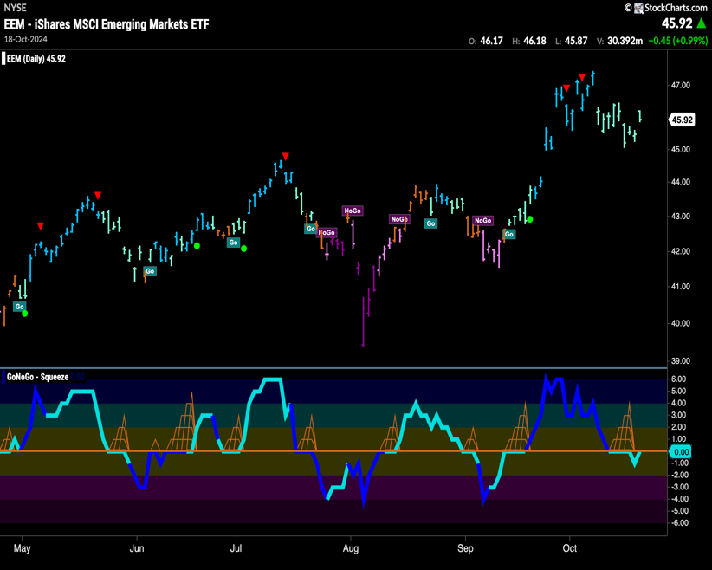Emerging Markets - $EEM

* GoNoGo Trend shows the “Go” trend survives but we continue to see weaker aqua bars for another week
* GoNoGo Oscillator remains at the zero line and we will watch to see if it can burst back into positive territory

# Commodities

# Gold - $GLD

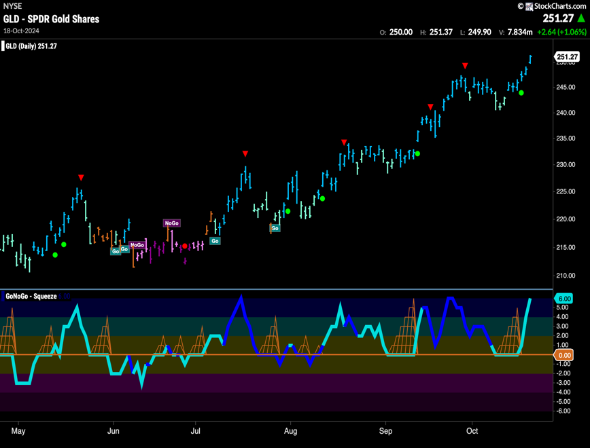

* GoNoGo Trend painted strong blue “Go” bars as price hit higher highs
* GoNoGo Oscillator is at a value of 6 and overbought

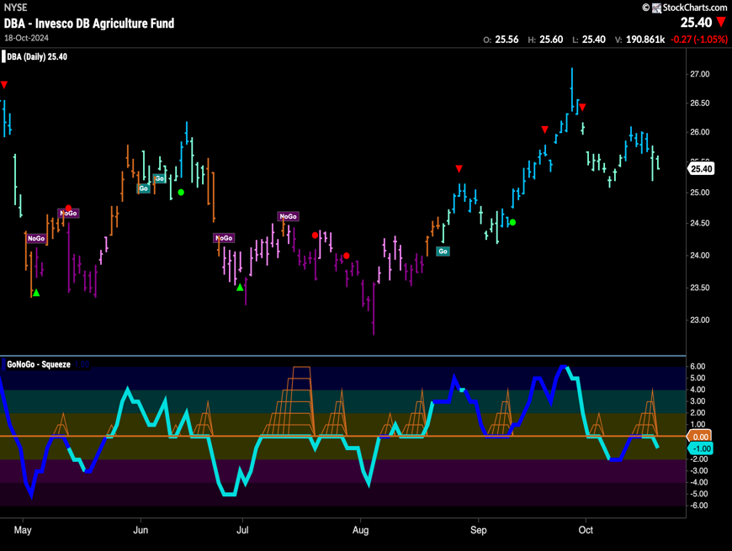Agriculture – $DBA

* GoNoGo Trend shows the “Go” trend has continued but we see weak aqua bars
* GoNoGo Oscillator has been turned away by the zero line back into negative territory

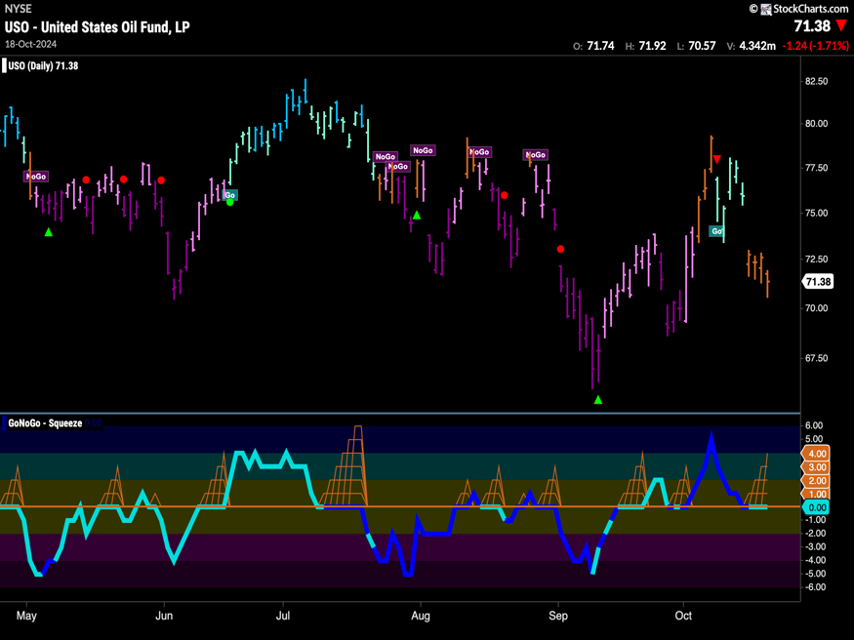Oil - $USO

* GoNoGo Trend shows amber “Go Fish” bars for most of this week after price gapped lower
* GoNoGo Oscillator is testing the zero line and we see a GoNoGo Squeeze

# Currencies

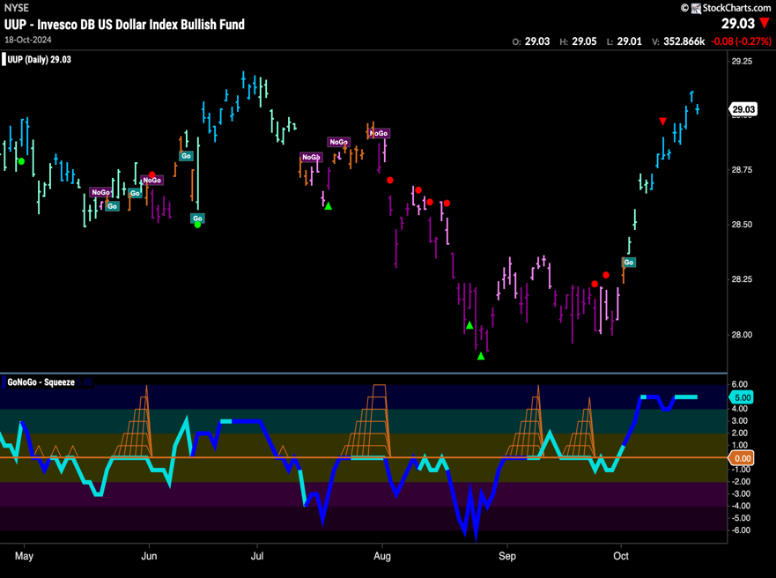The Dollar - $UUP

* GoNoGo Trend shows the “Go” trend stayed strong this week on more blue bars
* GoNoGo Oscillator remains in overbought territory at a value of 5

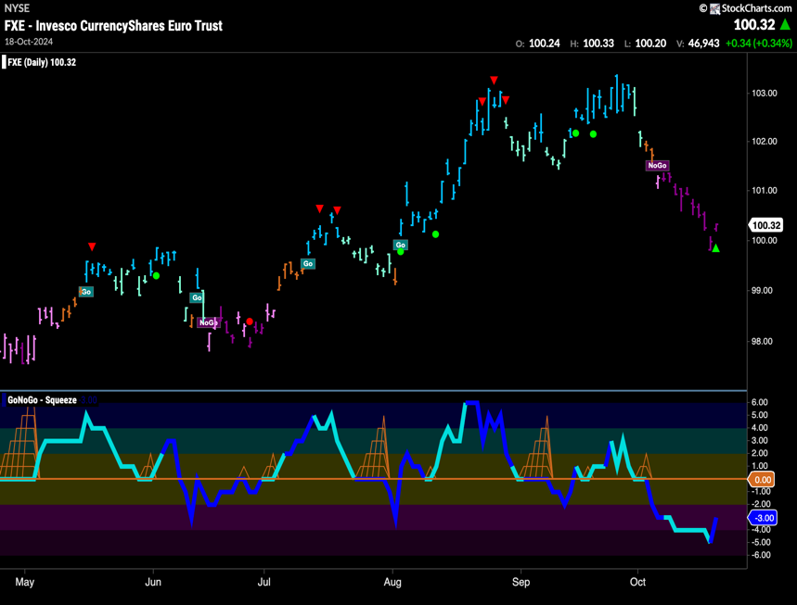The Euro - $FXE

* GoNoGo Trend shows that the “NoGo” stayed strong with purple bars
* GoNoGo Oscillator is in negative territory at a value of -3 and volume is increasing

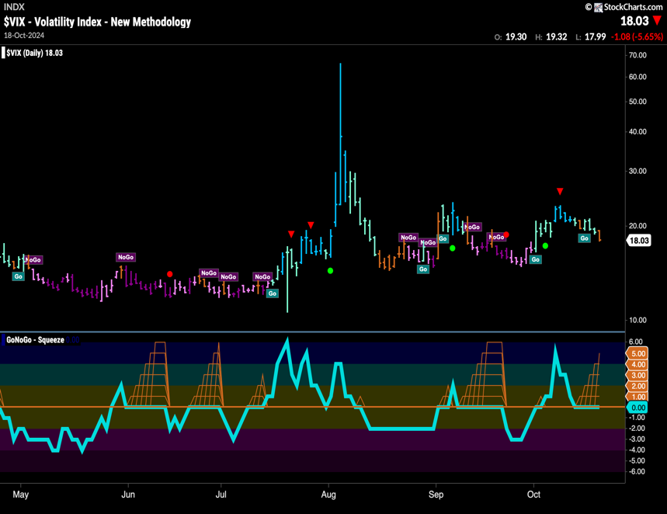Volatility - $VIX

* GoNoGo Trend shows volatility is painting an amber “Go Fish” bar as volatility goes nowhere
* GoNoGo Oscillator is riding the zero line and we see a GoNoGo Squeeze building

# Cryptocurrency

## Bitcoin - $BTCUSD

* GoNoGo Trend shows that the “Go” trend has found its feet with a week of strong blue bars
* GoNoGo Oscillator is at a value of 4 so not yet overbought

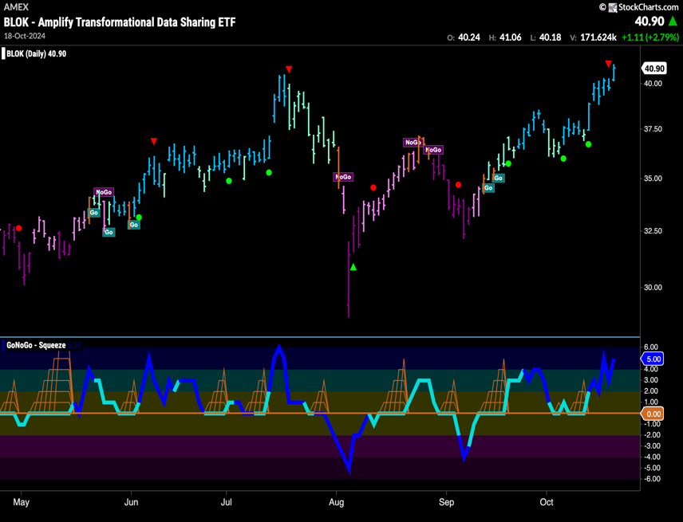Crypto Fund - $BLOK

* GoNoGo Trend shows that the trend remains in a “Go” trend and we see strong blue bars as price hits new highs
* GoNoGo Oscillator is back in overbought territory and volume is heavy

Top 5 Stocks in “Go” Trends

## Trend Continuation on Rising Momentum

GoNoGo Charts® highlight low-risk opportunities for trend participation with intuitive icons directly in the price action. The resurgence of momentum in the direction of the underlying price trend is an excellent entry opportunity, or the chance to scale up positions.

GoNoGo Icons® illuminate these events on the chart with green solid circles (or red circle to highlight continuation of NoGo trends). When GoNoGo Trend® is painting **blue** or **aqua** bars, a green solid circle will appear below price each time GoNoGo Oscillator® finds support at zero.

#### Below are the top 5 stocks/ETFs in “Go” trends with surging momentum by volume in the S&P 500 as of the daily closing price action:

### Palantir Technologies, Inc. – (PLTR)

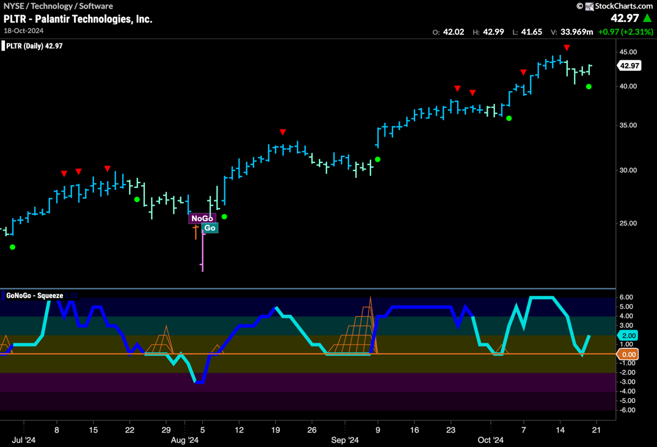

* GoNoGo Trend is painting a “Go” bar as we see signs of trend continuation as price tries to make a new high
* GoNoGo Oscillator has found support at the zero line

### AT&T, Inc (T)

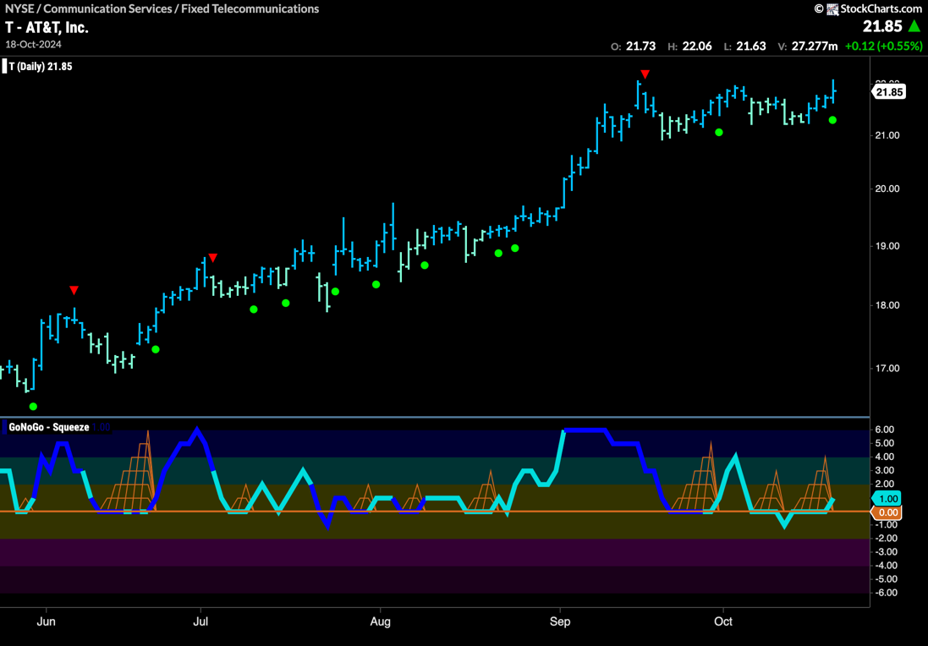

* GoNoGo Trend is painting a strong “Go” bar as price challenges for a new high
* GoNoGo Oscillator is breaking out of a GoNoGo Squeeze into positive territory

### Netflix, Inc (NFLX)

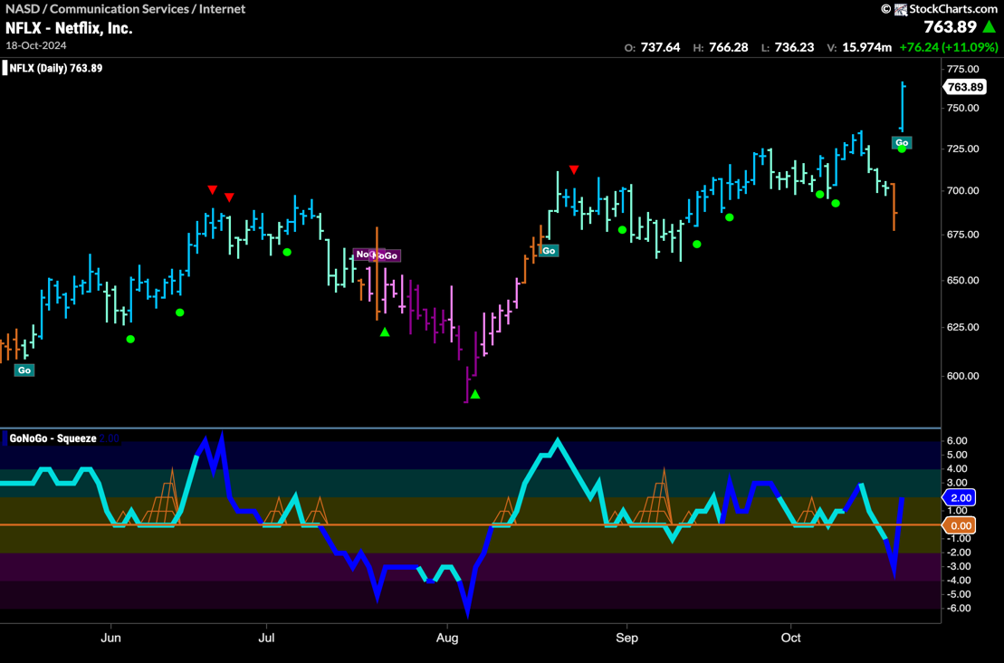

* GoNoGo Trend is painting a strong blue “Go” bar as price rallies to a new high
* GoNoGo Oscillator is rallying into positive territory on heavy volume

### Paypal Holdings, Inc (PYPL)

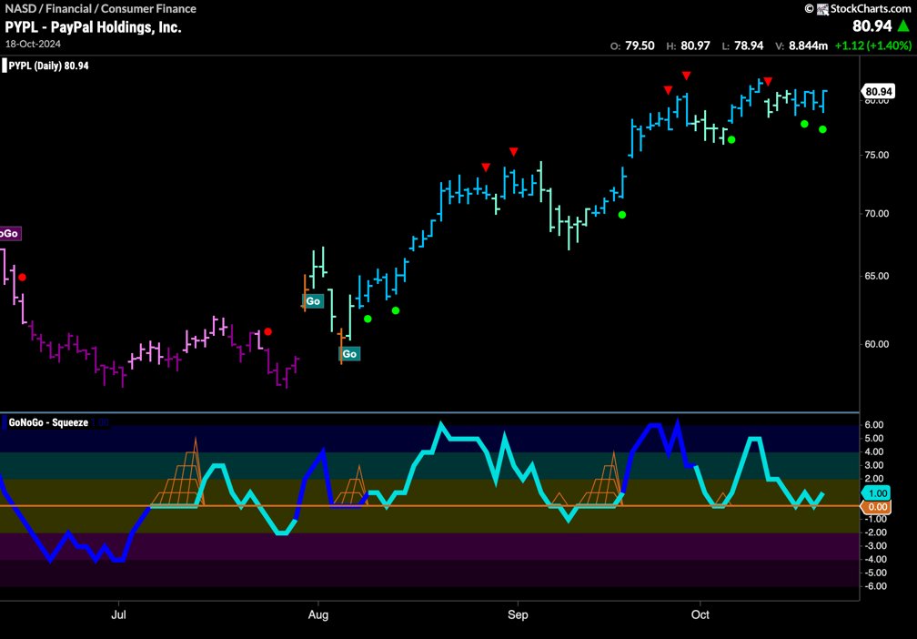

* GoNoGo Trend is painting strong blue bars as price looks to challenge for new highs
* GoNoGo Oscillator has again found support at zero

### Southwest Airlines Co. (LUV)

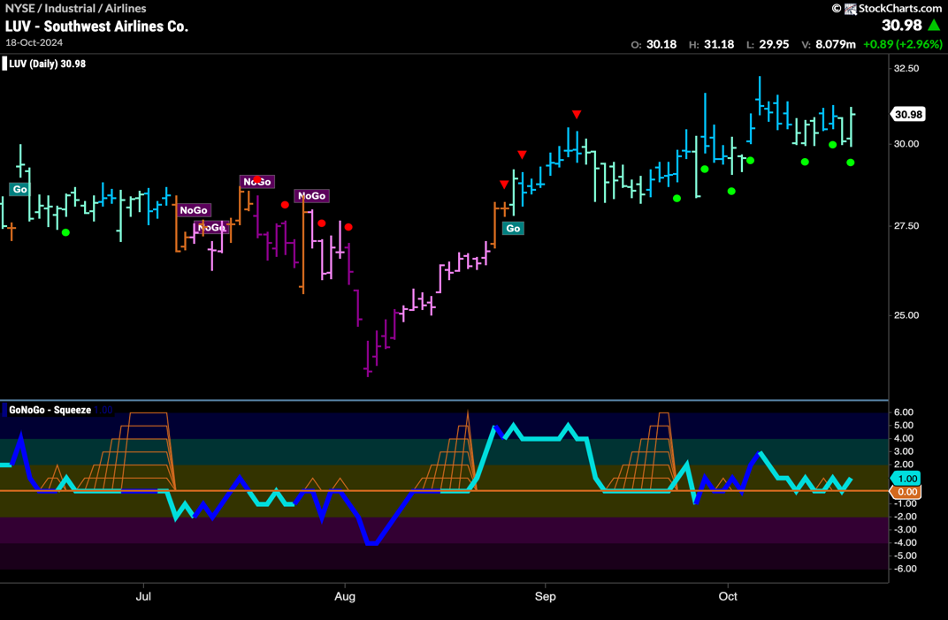

* GoNoGo Trend is painting aqua bars as price tries to set up for new highs
* GoNoGo Oscillator continues to find support at the zero line