# GoNoGo Heat Map®

## Cross-Asset Comparison of GoNoGo Trend

* Equities ended the week with a weaker pink “NoGo” bar after a week that started sharply down
* Treasury bond prices saw the “Go” trend remain in place with weaker aqua bars
* GoNoGo Trend shows that the “NoGo” persisted this week even as it painted a weaker pink bar
* Dollar saw the new “NoGo” trend remain in place but the indicator painted some weaker pink bars

# GoNoGo RelMap®

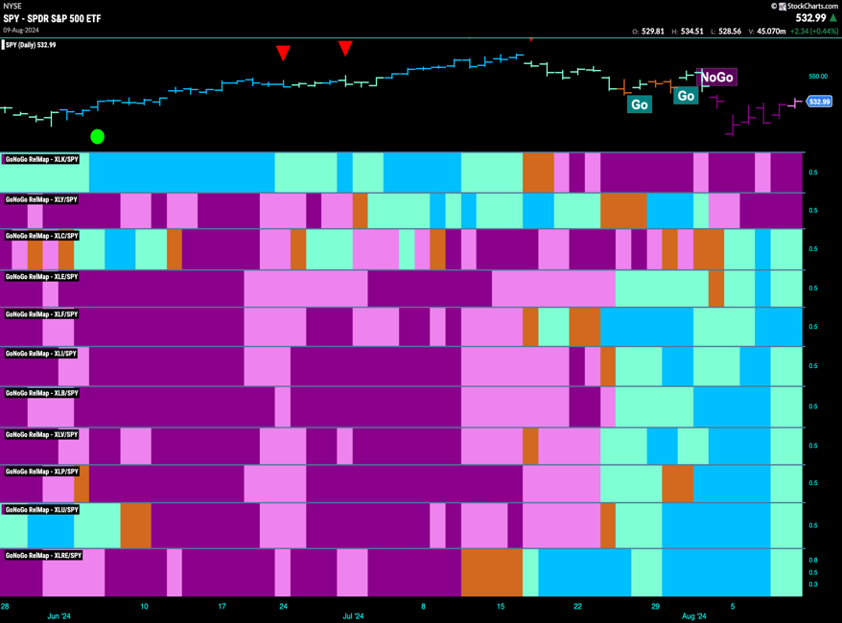GoNoGo Trend *of* Sectors’ Relative Strength to $SPX

* 9 sectors outperformed the broad S&P 500 Index to end this week
* $XLC, $XLE, $XLF, $XLI, $XLB, $XLV, $XLP, $XLU and $XLRE are in “Go” trends on a relative basis

# Fixed Income

## Investment Grade Corporate Bonds - $LQD

* GoNoGo Trend showed that the “Go” trend remained this week although we saw weaker aqua bars
* GoNoGo Oscillator found support at the zero line giving a Go Trend Continuation Icon on the price chart

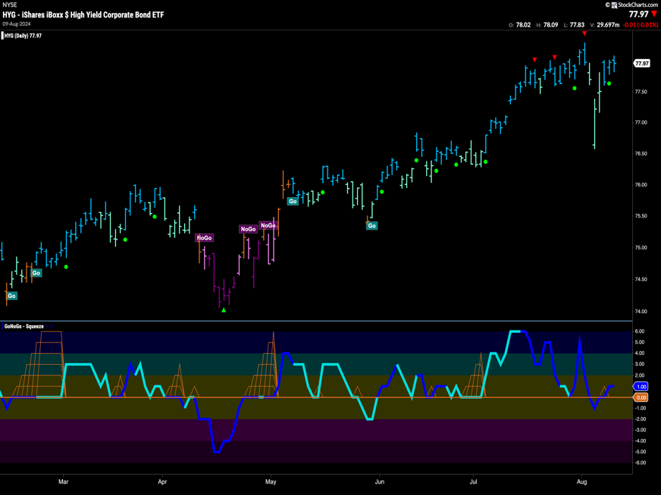High Yield Bonds - $HYG

* GoNoGo Trend saw the “Go” trend return to strength this week as the indicator paints bright blue bars
* GoNoGo Oscillator is back in positive territory and volume is heavy

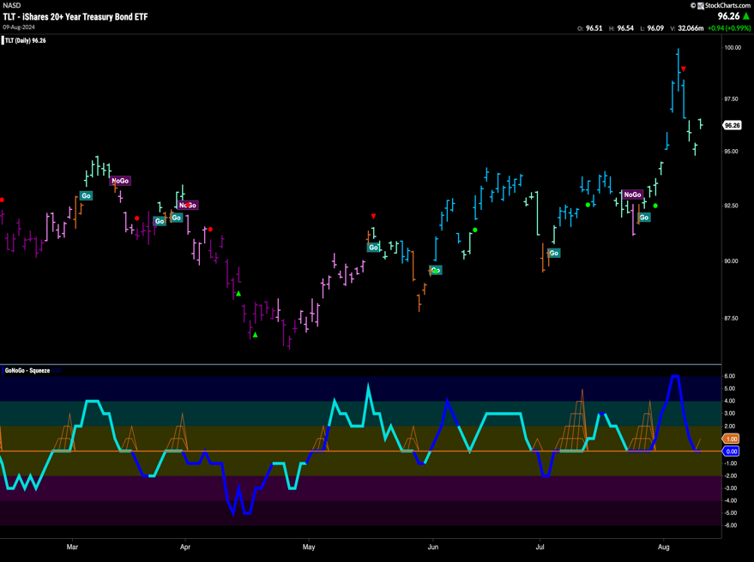Government Treasury Bonds - $TLT

* GoNoGo Trend shows the “Go” trend survived but the indicator paints weaker aqua bars after price dropped sharply
* GoNoGo Oscillator is testing the zero line from above and volume is heavy

# spy Equities

## U.S. Large Cap - $SPY

* GoNoGo Trend paints a string of “NoGo” bars although the indicator paints weaker pink after price rallied all week
* GoNoGo Oscillator is testing the zero level from below where we will watch to see if it finds resistance and volume is heavy

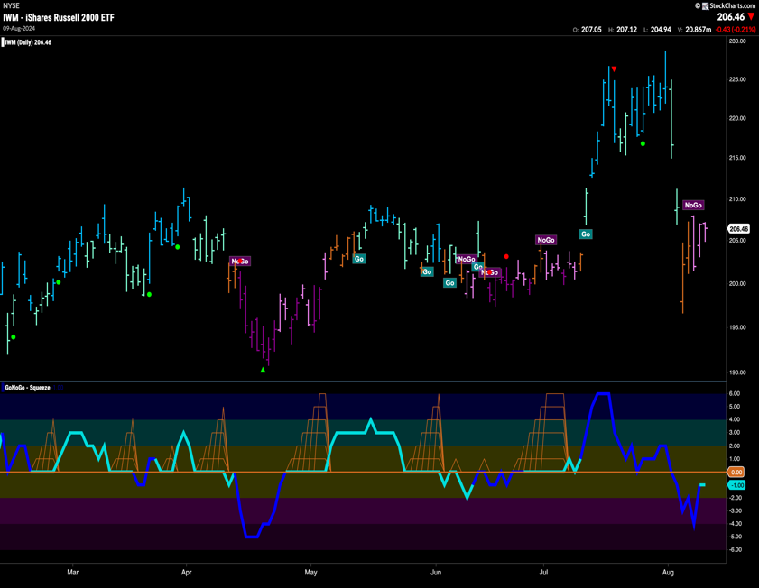U.S. Small Cap - $IWM

* GoNoGo Trend shows that after an amber “Go Fish” bar the indicator painted weaker “NoGo” bars this week
* GoNoGo Oscillator is in negative territoroy but no longer oversold

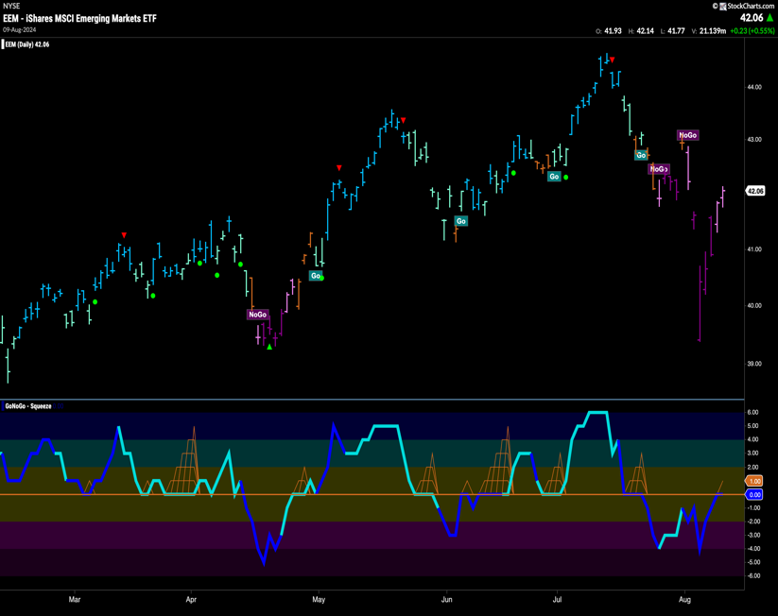Emerging Markets - $EEM

* GoNoGo Trend shows that the “NoGo” trend remains in place although we see weaker pink bars after price rallied this week
* GoNoGo Oscillator is testing the zero level from below and volume is heavy

# Commodities

# Gold - $GLD

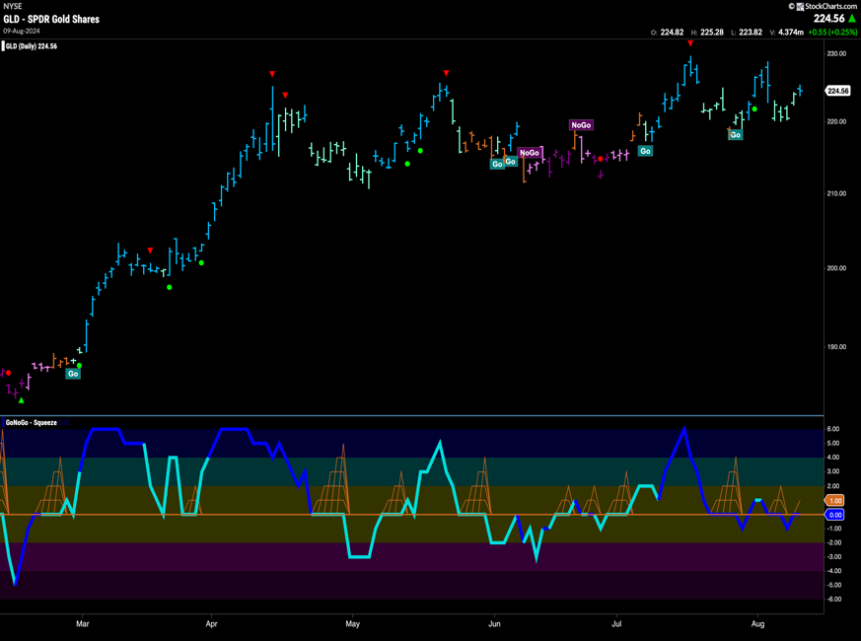

* GoNoGo Trend shows that the “Go” trend is still in place and the indicator showed a return to strength on the final bar of the week
* GoNoGo Oscillator is struggling to distance itself from the zero line and volume remains heavy

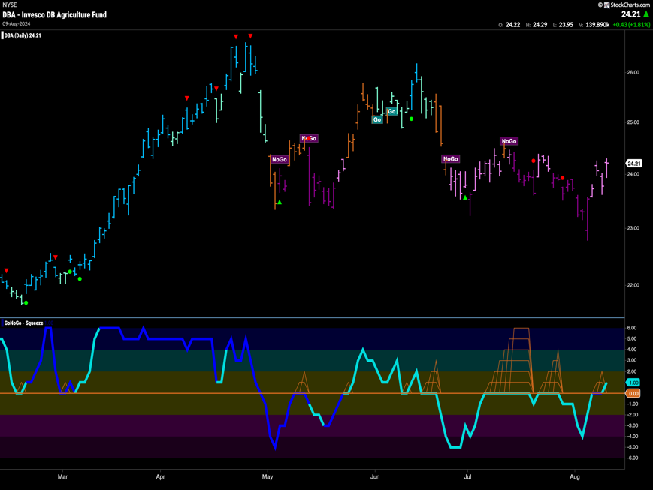Agriculture – $DBA

* GoNoGo Trend shows that the “NoGo” remained in place this week but we did see weakness with pink bars as prices rallied
* GoNoGo Oscillator is dipping its nose into positive territory after breaking through the zero line

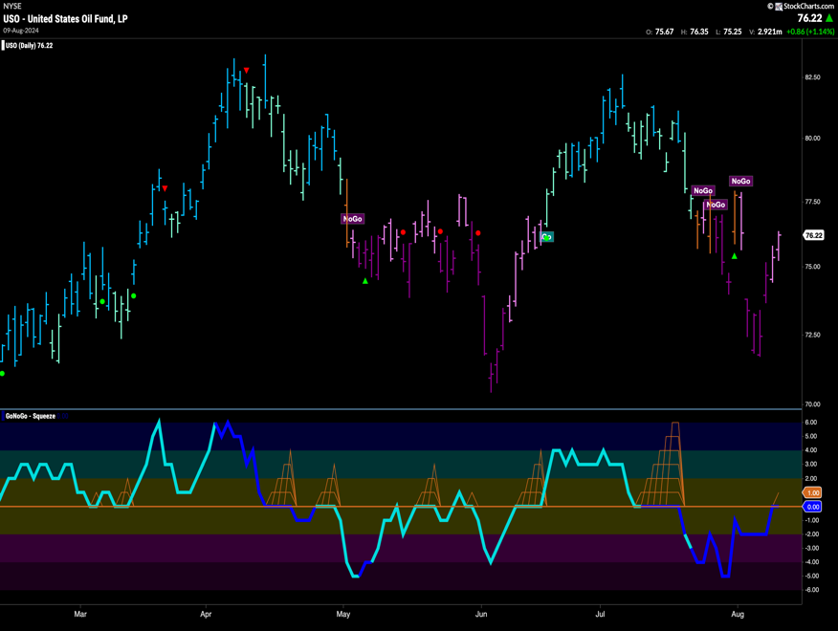Oil - $USO

* GoNoGo Trend shows the “NoGo” trend survived this week although we saw weaker pink bars as prices bounced off lows
* GoNoGo Oscillator is testing the zero line from below where we will watch to see if it finds resistance and volume is heavy

# Currencies

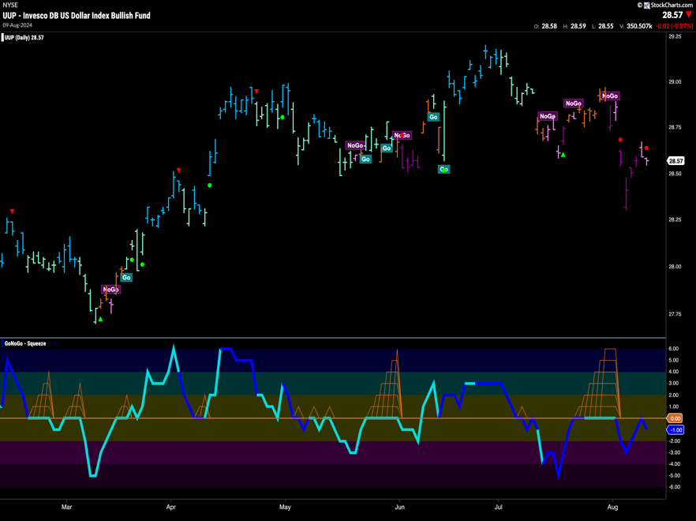The Dollar - $UUP

* GoNoGo Trend shows that the “NoGo” remained in place although we saw weaker pink bars
* GoNoGo Oscillator has been rejected by the zero line from below and volume is heavy

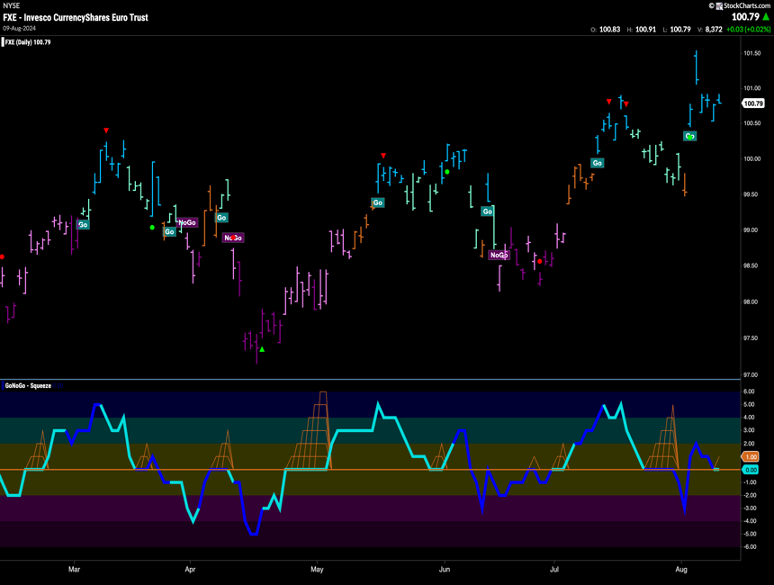The Euro - $FXE

* GoNoGo Trend shows the “Go” trend remains and we saw strength this week as price hit a new high
* GoNoGo Oscillator is testing the zero line from above where we will watch to see if it finds support

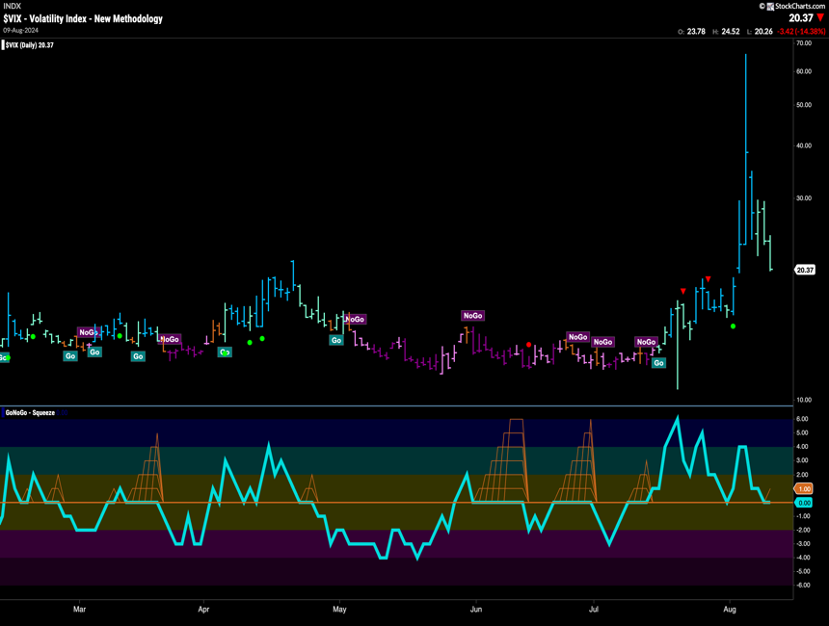Volatility - $VIX

* GoNoGo Trend shows volatility hit extreme highs this week and stayed in its “Go” trend
* GoNoGo Oscillator is testing the zero line from above where we will watch to see if it finds support

# Cryptocurrency

## Bitcoin - $BTCUSD

* GoNoGo Trend shows that the trend remains a “NoGo” although the bars are weaker pink
* GoNoGo Oscillator is testing the zero line from below where we will watch to see if we find resistance and volume is heavy

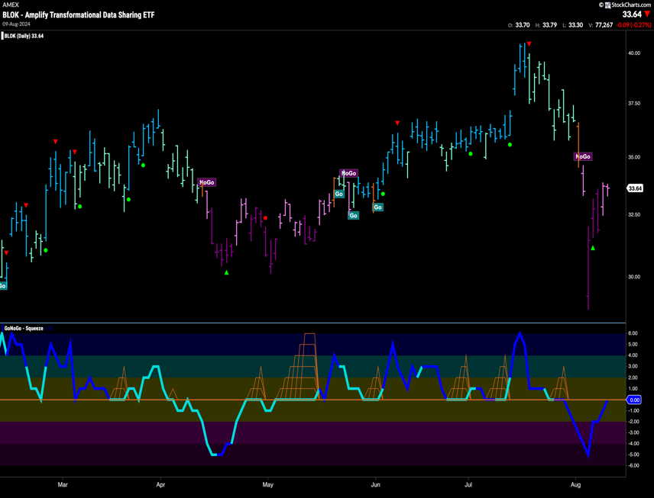Crypto Fund - $BLOK

* GoNoGo Trend paints weaker “NoGo” bars after new lows this week
* GoNoGo Oscillator is testing the zero line from below and volume is heavy

Top 5 Stocks in “Go” Trends

## Trend Continuation on Rising Momentum

GoNoGo Charts® highlight low-risk opportunities for trend participation with intuitive icons directly in the price action. The resurgence of momentum in the direction of the underlying price trend is an excellent entry opportunity, or the chance to scale up positions.

GoNoGo Icons® illuminate these events on the chart with green solid circles (or red circle to highlight continuation of NoGo trends). When GoNoGo Trend® is painting **blue** or **aqua** bars, a green solid circle will appear below price each time GoNoGo Oscillator® finds support at zero.

#### Below are the top 5 stocks/ETFs in “Go” trends with surging momentum by volume in the S&P 500 as of the daily closing price action:

### Akamai Technologies, Inc. (AKAM)

* GoNoGo Icons signaled a trend continuation on Friday (08/09/24).
* After a multi-month NoGo trend beginning in February, price action based at $88 and reversed to a Go trend in July.
* After a retest during this week’s volatility, AKAM finished the week on strong “Go” conditions after gapping higher on a **blue** bar.
* GoNoGo Oscillator broke out from below the zero line ending at positive 2 on Friday.
* AKAM has traded on heavy relative volume all week.

### Raytheon Technologies Corp. (RTX)

* GoNoGo Trend held weak form “Go” conditions this week on pale **aqua** bars.
* GoNoGo Icons signaled a trend continuation on Friday (08/09/24).
* GoNoGo Oscillator ended the week in positive territory after retesting the zero line and finding support.

### Healthpeak Properties, Inc. (DOC)

* GoNoGo Trend sustained “Go” conditions throughout the trading week.
* GoNoGo Icons signaled a trend continuation on Tuesday and Friday (08/09/24) as momentum found support at neutral
* GoNoGo Oscillator ended the week in positive territory after testing the zero line on heavy relative volume.

### United Dominion Realty Trust (UDR)

* GoNoGo Trend returned to strong **blue** “Go” conditions after painting a pink NoGo bar during Monday’s selloff.
* This recovery follows weakening trend conditions and corrective price action in late July.
* GoNoGo Icons signaled a trend continuation on Friday (08/09/24).
* GoNoGo Oscillator recently dipped into negative territory, but recovered positive momentum conditions on Friday.

### Progressive Corp. (PGR)

* GoNoGo Trend ended the trading week on strong **blue** “Go” conditions.
* GoNoGo Icons signaled a trend continuation on Friday (08/09/24).
* GoNoGo Oscillator has built three max squeeze conditions as price action became range bound through the summer months.
* Momentum delivered a false breakdown on Monday before breaking back into positive territory again on Friday.