GoNoGo Heat Map®

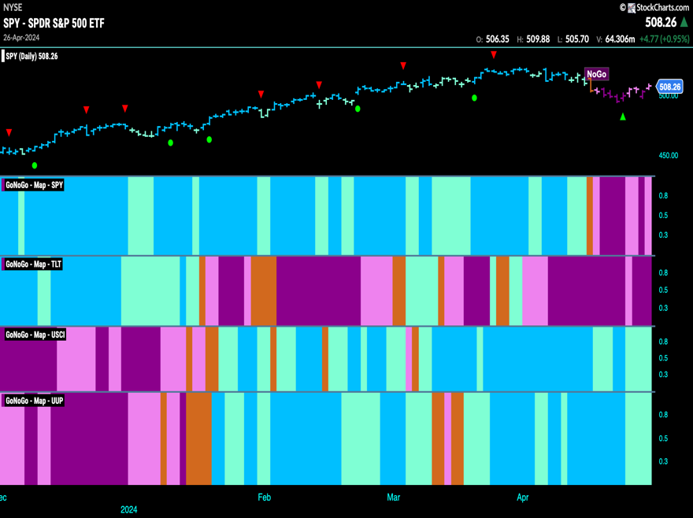
Cross-Asset Comparison of GoNoGo Trend
- Equities sees the “NoGo” continue this week but on weaker pink bars
- Treasury bond prices see continued “NoGo” strength as purple bars dominate
- Commodities show weakness in the “Go” trend with paler aqua bars
- Dollar remained in a “Go” trend but also showed weakness with aqua bars

GoNoGo RelMap®
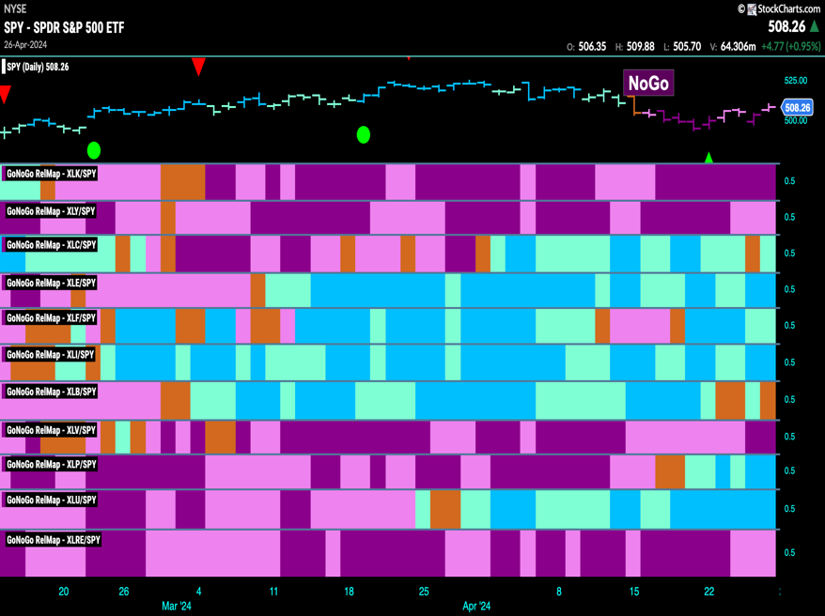
GoNoGo Trend of Sectors’ Relative Strength to $SPX
- 6 sectors outperformed the broad S&P 500 Index to end this week
- $XLC, $XLF, $XLE, $XLI, $XLP and $XLU are in “Go” trends on a relative basis

Fixed Income

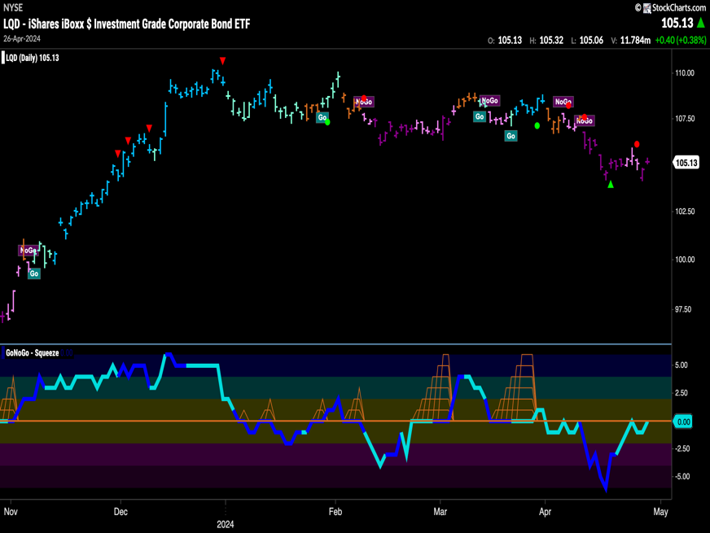
Investment Grade Corporate Bonds - $LQD
- GoNoGo Trend saw the “NoGo” continue and strengthen at the end of the week with purple bars
- GoNoGo Oscillator is testing the zero line from below where we will watch to see if it finds resistance

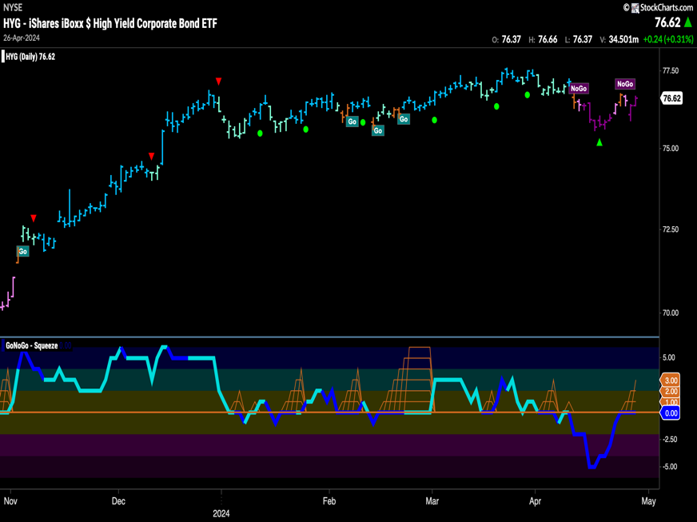
High Yield Bonds - $HYG
- GoNoGo Trend saw the “NoGo” trend strengthen to paint purple bars
- GoNoGo Oscillator is testing the zero line from below where we will watch to see if it finds resistance

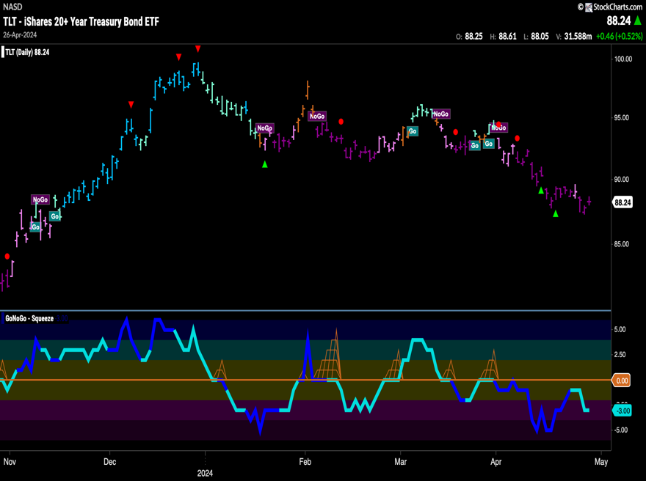
Government Treasury Bonds - $TLT
- GoNoGo Trend shows strong “NoGo” bars after price made a new low
- GoNoGo Oscillator is in negative territory but not oversold

spy Equities

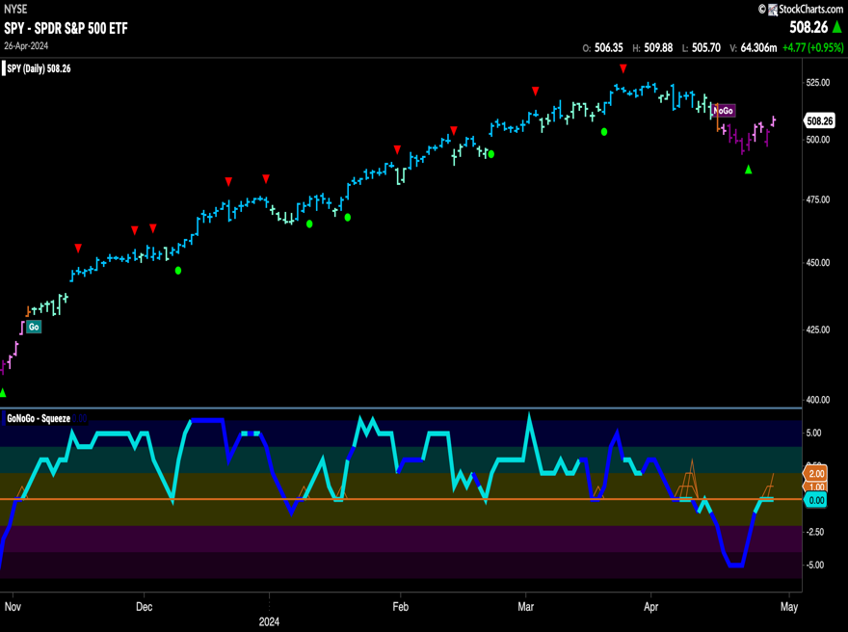
U.S. Large Cap - $SPY
- GoNoGo Trend sees the “NoGo” weaken and paint pink bars
- GoNoGo Oscillator is testing the zero line from below where we will watch to see if it finds resistance

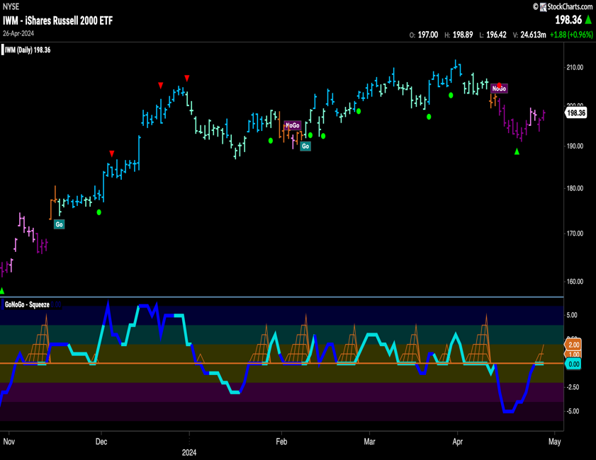
U.S. Small Cap - $IWM
- GoNoGo Trend shows the “NoGo” remained strong this week as it paints purple bars
- GoNoGo Oscillator is testing the zero line from below where we will watch to see if it finds resistance

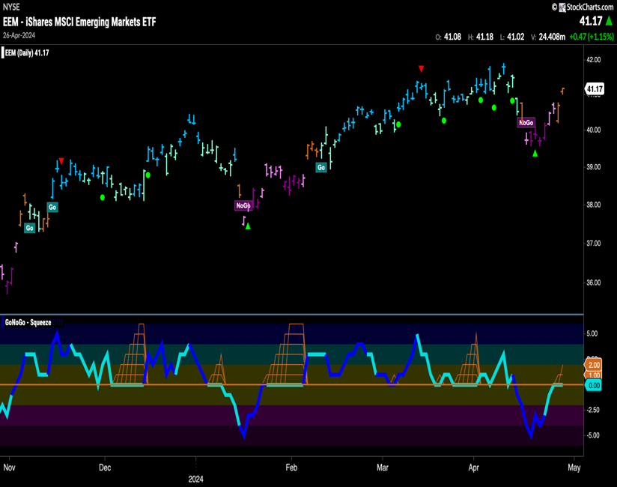
Emerging Markets - $EEM
- GoNoGo Trend shows amber “Go Fish” bars as the market is uncertain about the “NoGo” trend
- GoNoGo Oscillator is testing the zero line from below where we will watch to see if it finds resistance

Commodities

Gold - $GLD
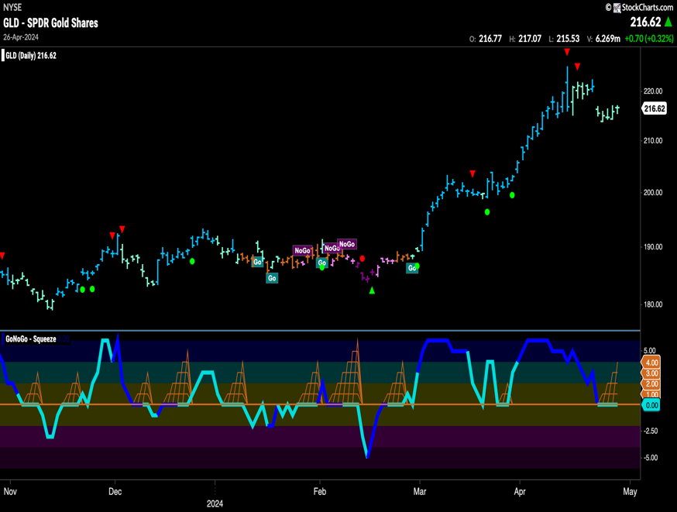
- GoNoGo Trend shows the trend remains but we see weaker aqua bars this week as price fell from highs
- GoNoGo Oscillator is testing the zero line from above where we will watch to see if it finds support

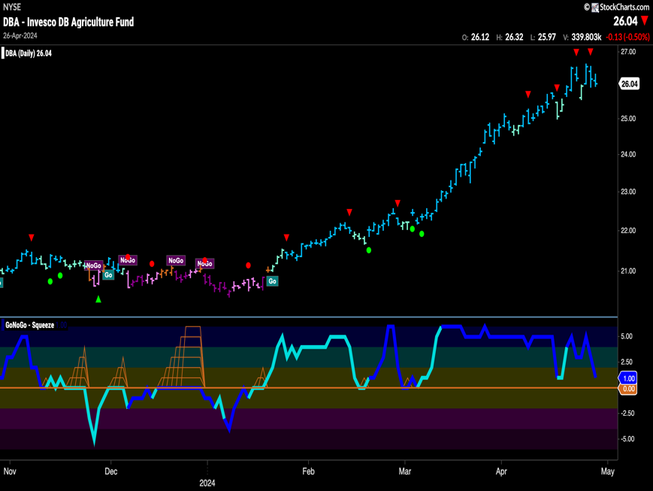
Agriculture – $DBA
- GoNoGo Trend painted strong blue bars again this week as price stays close to highs
- GoNoGo Oscillator is in positive territory but not overbought and volume is heavy

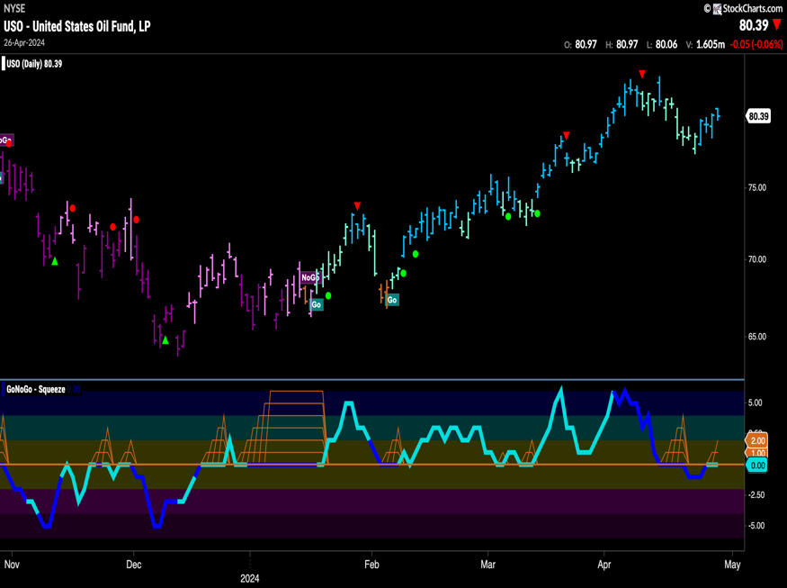
Oil - $USO
- GoNoGo Trend shows the “Go” trend has strengthened this week as price rallies on blue bars
- GoNoGo Oscillator is back at the zero line and we will watch to see if it can regain positive territory

Currencies
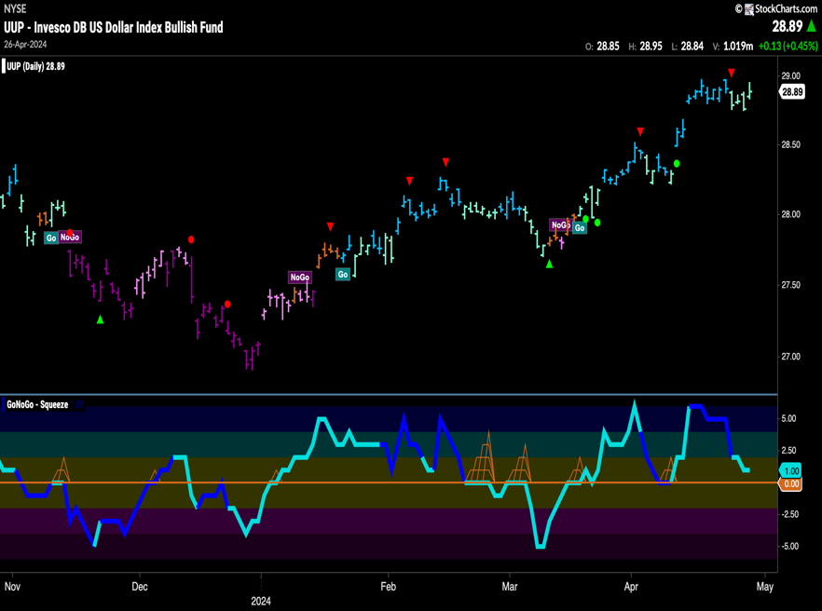
The Dollar - $UUP
- GoNoGo Trend shows the “Go” trend consolidating at highs with weaker aqua bars
- GoNoGo Oscillator is approaching the zero line from above and we will watch to see if it finds support

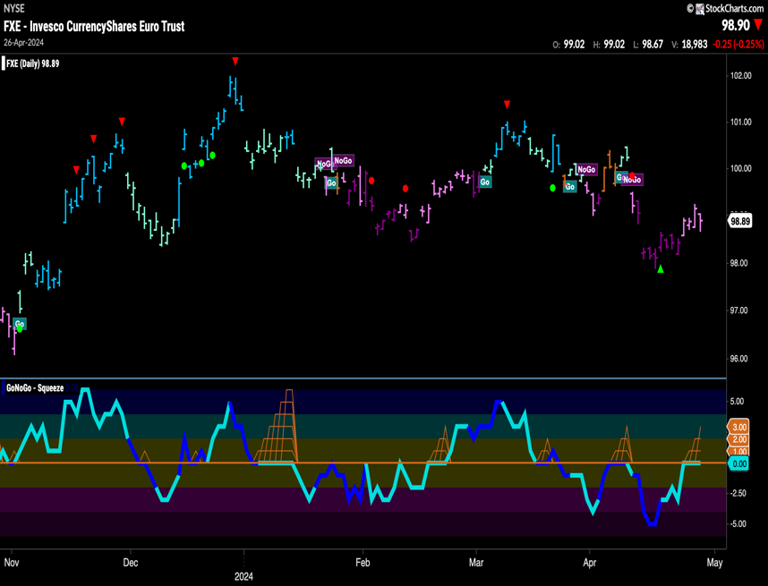
The Euro - $FXE
- GoNoGo Trend paints weaker pink bars at the end of the week as the “NoGo” struggles a little
- GoNoGo Oscillator is testing the zero line from below where we will watch to see if it finds resistance

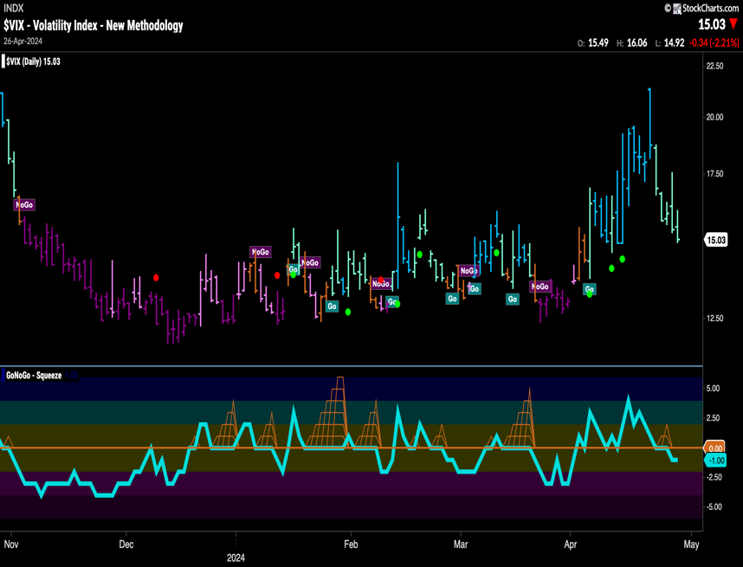
Volatility - $VIX
- GoNoGo Trend shows weaker aqua “Go” bars this week
- GoNoGo Oscillator is dipping into negative territory this week

Cryptocurrency

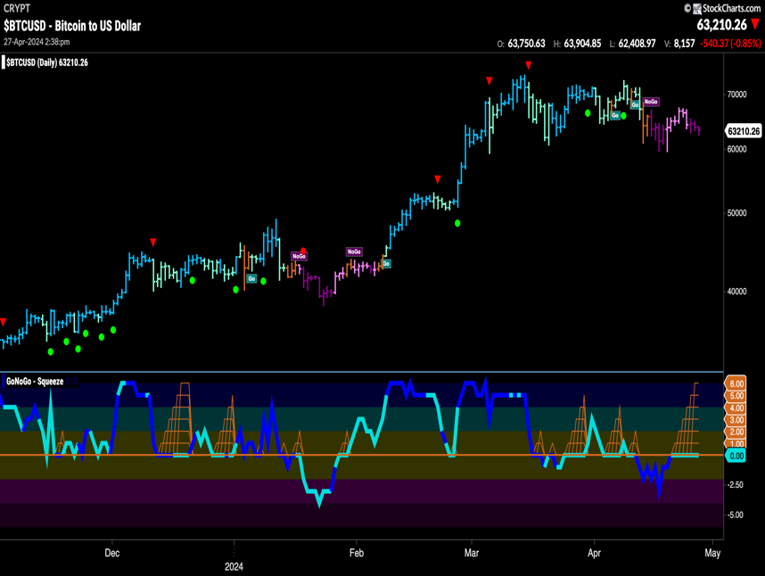
Bitcoin - $BTCUSD
- GoNoGo Trend painted strong purple “NoGo” bars as this week ended
- GoNoGo Oscillator is testing the zero line from below where we will watch to see if it finds resistance

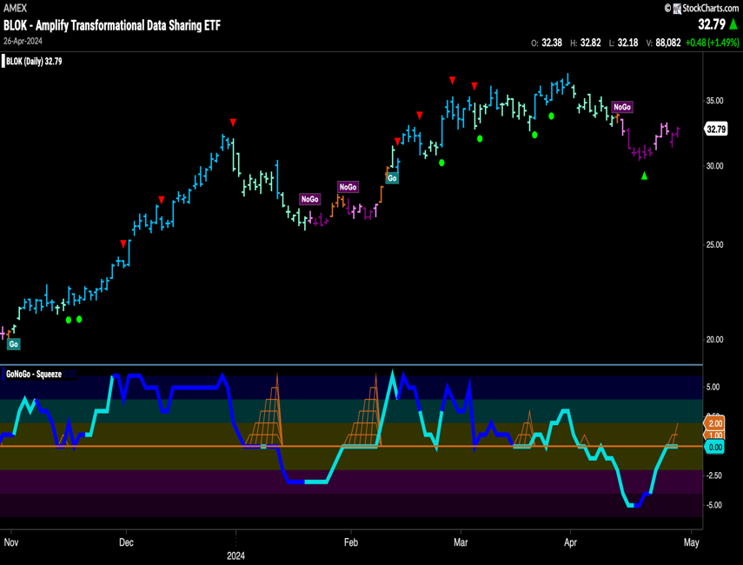
Crypto Fund - $BLOK
- GoNoGo Trend painted strong “NoGo” as this week came to a close
- GoNoGo Oscillator is testing the zero line from below where we will watch to see if it finds resistance

Top 5 Stocks in “Go” Trends

Trend Continuation on Rising Momentum

GoNoGo Charts® highlight low-risk opportunities for trend participation with intuitive icons directly in the price action. The resurgence of momentum in the direction of the underlying price trend is an excellent entry opportunity, or the chance to scale up positions.
GoNoGo Icons® illuminate these events on the chart with green solid circles (or red circle to highlight continuation of NoGo trends). When GoNoGo Trend® is painting blue or aqua bars, a green solid circle will appear below price each time GoNoGo Oscillator® finds support at zero.

Below are the top 5 stocks/ETFs in “Go” trends with surging momentum by volume in the S&P 500 as of the daily closing price action:

SNAP Inc - (SNAP)
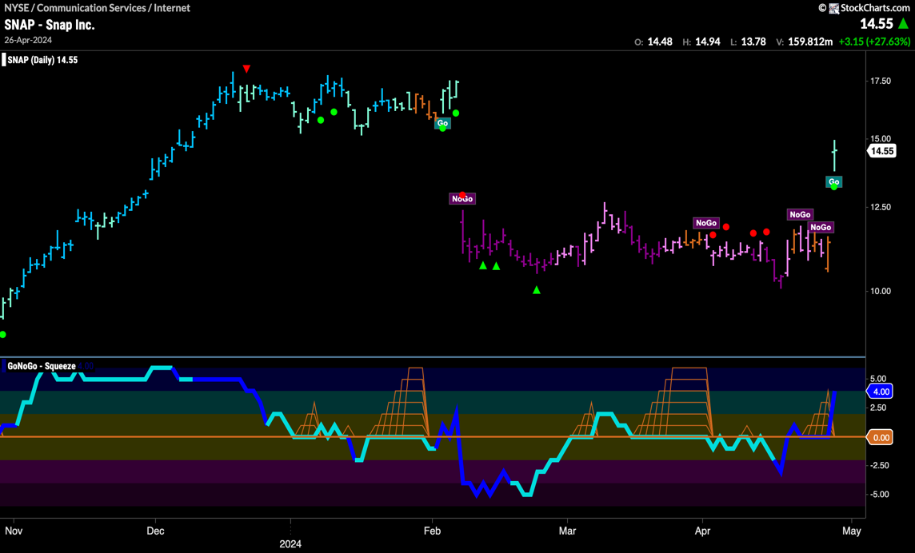
- GoNoGo Trend shows a new “Go” trend with an aqua bar
- Price gapped higher and is testing the top of the prior gap down
- GoNoGo Oscillator has rallied back into positive territory on heavy volume as we see a Go Trend Continuation Icno (green circle) indicating that momentum is surging in the direction of the new trend

Alphabet Inc (GOOGL)
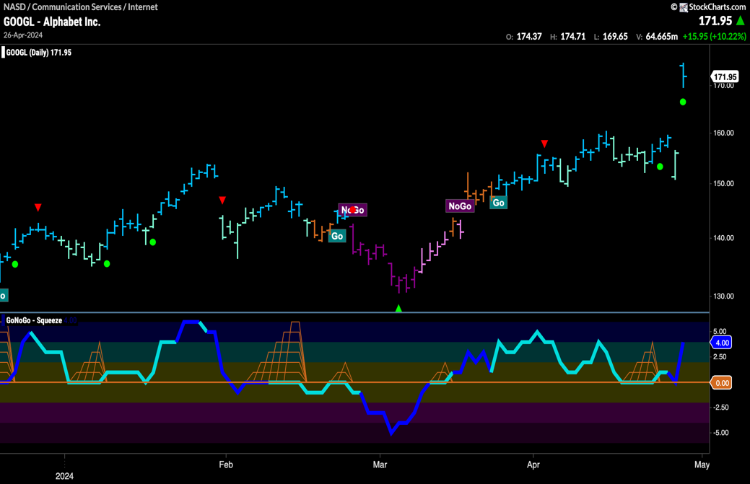
- GoNoGo Trend showed a fresh bright blue “Go” bar
- Price gapped to new highs as momentum was strong
- GoNoGo Oscillator rallied into positive territory on heavy volume as we see a Go Trend Continuation Icon (green circle) under the price bar

Lloyds TSB Group Plc (LYG)
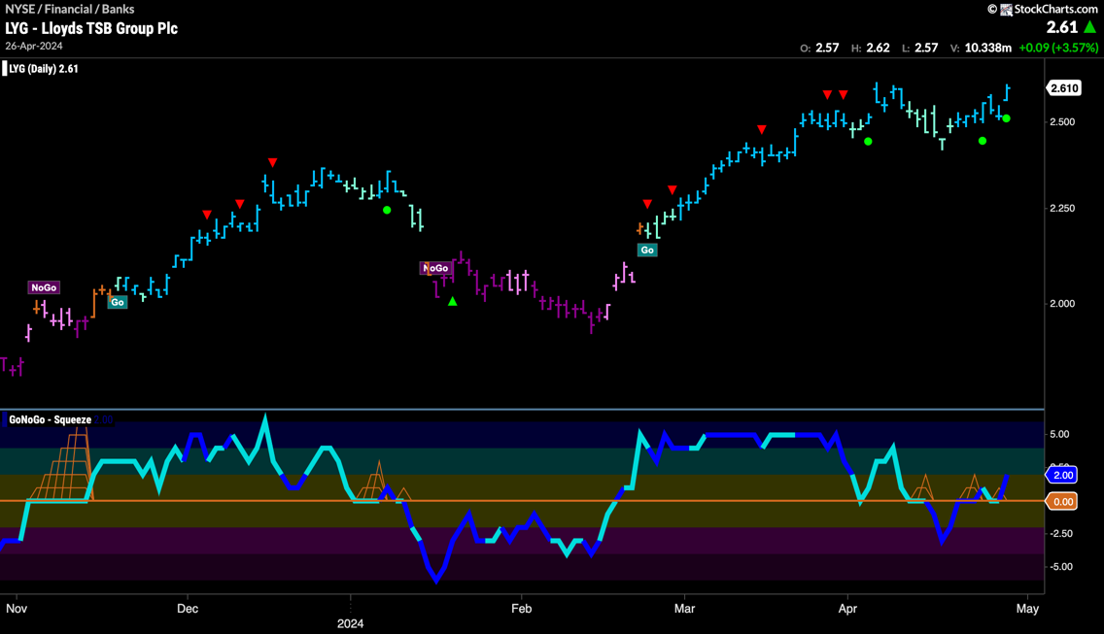
- GoNoGo Trend paints a string of strong blue “Go” bars as price tests prior high resistance
- GoNoGo Oscillator bounced off the zero line on heavy volume as we see a Go Trend Continuation Icon (green circle) under the price bar

Alcoa Corp (AA)
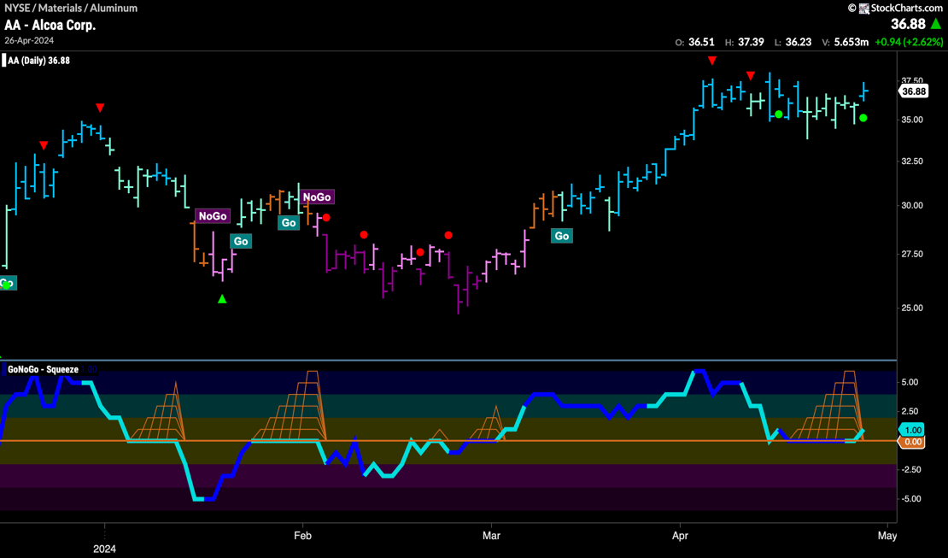
- GoNoGo Trend returned to strong blue “Go” conditions to conclude the trading week as price rose to test prior high resistance
- GoNoGo Oscillator breaks out of a Max GoNoGo Squeeze into positive territory and we see a Go Trend Continuation Icon (green circle) under the price bar

IAG Gold Mining (IAG)
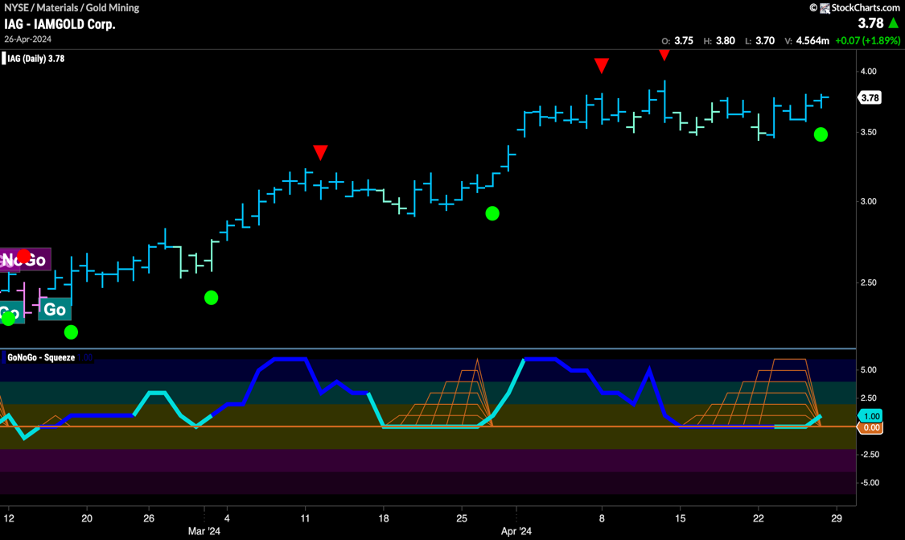
- GoNoGo Trend painted strong blue “Go” bars as price runs up against prior high resistance
- GoNoGo Oscillator is breaking out of a Max GoNoGo Squeeze into positive territory and we see a Go Trend Continuation Icon (green circle) under the price bar

